

HOUSING PRICE PREDICTION PROJECT

Prepared by:

Sidda Lakshmi praneetha

# ACKNOWLEDGMENT

Firstly, I would like to thank FlipRobo Technologies for giving me the opportunity to work on this project. Also, I would like to thank the DataTrained team, especially Khushboo Garg Ma'am for providing

me the guidance which helped me a lot to work on the project.

**References:** <https://stackoverflow.com/> <https://scikit-learn.org/stable/> <https://seaborn.pydata.org/>

# INTRODUCTION

## Business Problem Framing

The main objective of this project is to model the price of houses with the available independent variables. This model will then be used by the management to understand how exactly the prices vary with the variables. They can accordingly manipulate the strategy of the firm and concentrate on areas that will yield high returns.

Further, the model will be a good way for the management to understand the pricing dynamics of a new market.

## Conceptual Background of the Domain Problem

Houses are one of the necessary need of each and every person around the globe and therefore housing and real estate market is one of the markets which is one of the major contributors in the world’s economy. It is a very large market and there are various companies working in the domain. Data science comes as a very important tool to solve problems in the domain to help the companies increase their overall revenue, profits, improving their marketing strategies and focusing on changing trends in house sales and purchases. Predictive modelling, Market mix modelling, recommendation systems are some of the machine learning techniques used for achieving the business goals for housing companies. Our problem is related to one such housing company.

## Technical Requirements

* + Data contains 1460 entries each having 81 variables.
  + Data contains Null values. We need to treat them using the domain knowledge and your own understanding.
  + Extensive EDA has to be performed to gain relationships of variable and price.
  + Data contains numerical as well as categorical variable. We need to handle them accordingly.
  + We have to build Machine Learning methods, apply regularization and determine the optimal values for Hyper Parameters.
  + We need to find important features which affect the price positively or negatively.
  + Two datasets are being provided to us (test.csv, train.csv).

## ADVANTAGES:

1. The objective behind to take this project is to implement the required data science skills.
2. Improve the analytical thinking.
3. Get into the real world problem solving mechanics.

# Analytical Problem Framing

## Mathematical Modeling of the Problem:

This is a Regression problem, where our end goal is to predict the Prices of House, based on given data provided in the dataset. We have divided the provided dataset into Training and Testing phases.

A Regression Model will be built and trained using the Training data and the Test data is used to predict the outcomes. This will be compared with available test results to find how our model has performed.

We are using Mean Absolute Error, Root Mean Square Error, and ‘R2_Score’ to determine the best model among,

* Linear Regression
* Decision Tree Regression
* Random Forest Regression
* K Neighbors Regression
* Lasso Regression

The best results were obtained using Lasso Regression. So, let’s discuss a little bit about it. In a simple regression problem (a single x and a single y), the form of the model would be:

### y = B0 + B1*x

where **B0** —intercept, **B1** —coefficient, **x** —independent variable

**y** — output or the dependent variable.

In higher dimensions when we have more than one input (x), The General equation for a Multiple linear regression with p — independent variables:

### Y=B0 + B1 * X1 + B2 * X2 + + Bp * Xp + E(Random Error or

**Noise)**

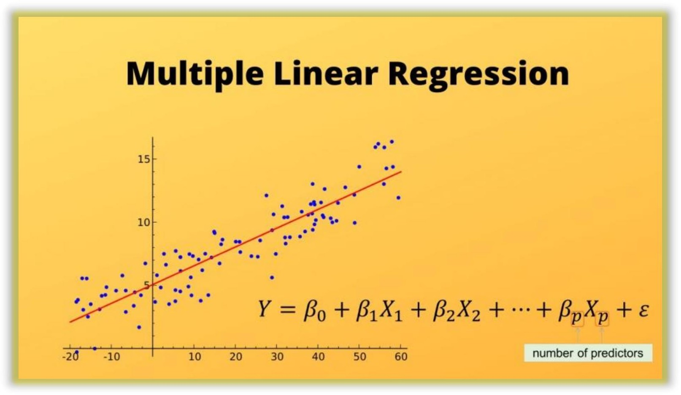

Let’s consider a regression scenario where ‘y’ is the predicted vector and ‘x’ is the feature matrix. Basically in any regression problem, we try to minimize the squared error. Let ‘β’ be the vector of parameters (weights of importance of features) and ‘p’ be the number of features.

Now, let’s discuss the case of lasso regression, which is also called L1 regression since it uses the L1 norm for regularization. In lasso regression, we try to solve the below minimization problem:



To simplify, suppose p =1, βi = β. Then,

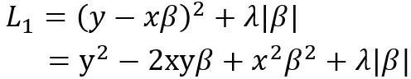In Lasso Regression, the L1 penalty will look like, L1p = |β1| + |β2|

Shrinking β1 to 8 and β2 to 100 would minimize the penalty to 108 from 1010, which means in this case the change is not so significant

just by shrinking the larger quantity. So, in the case of the L1 penalty, both the coefficients have to be shrunk to extremely small values, in order to achieve regularization. And in this whole process, some coefficients may shrink to zero.

(Reference: [https://www.analyticsvidhya.com/blog/2020/11/lasso-regression-causes-](https://www.analyticsvidhya.com/blog/2020/11/lasso-regression-causes-sparsity-while-ridge-regression-doesnt-unfolding-the-math/) sparsity-while-ridge-regression-doesnt-unfolding-the-math/ )

### Assumptions:

1. **Linearity:** The relationship between X & mean of Y is linear.
2. **Homoscedasticity:** The variance of residual is the same for any value of X.
3. **Independence:** Observations are independent of each other.
4. **Normality:** For any fixed value of X, Y is normally distributed.

## Data Sources and their formats

A US-based housing company named Surprise Housing has decided to enter the Australian market. The company uses data analytic to purchase houses at a price below their actual values and flip them at a higher price. For the same purpose, the company has collected a data set from the sale of houses in Australia. The data is provided in the CSV file below.

The dataset contains 1460 rows and 81 columns (including the train dataset and test dataset).

The top 5 rows of the dataset are:

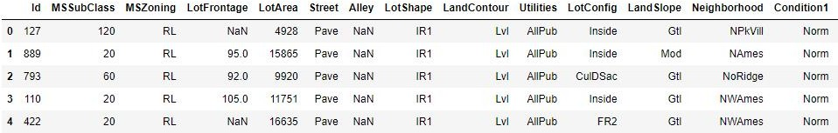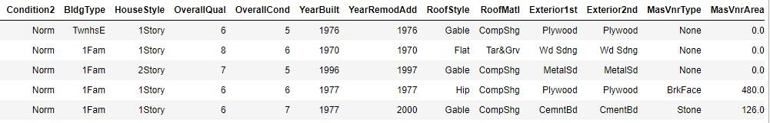

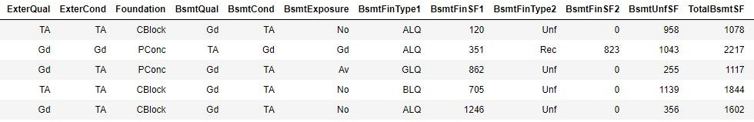

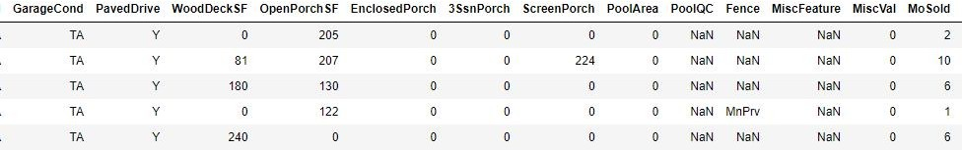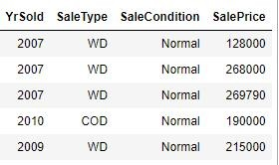

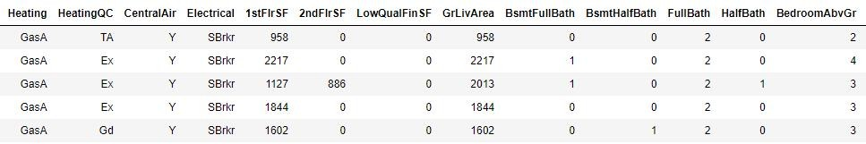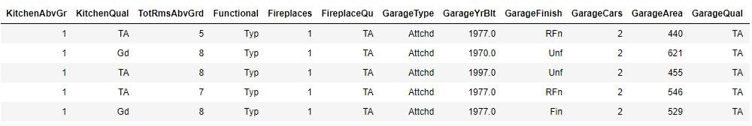

* + The column **‘SalePrice’** is the target column. We need to predict the sale price of the houses.

## Data Preprocessing Done

As our dataset contains null values (missing values) so we have replace the missing values with the required values. Details are mentioned below:

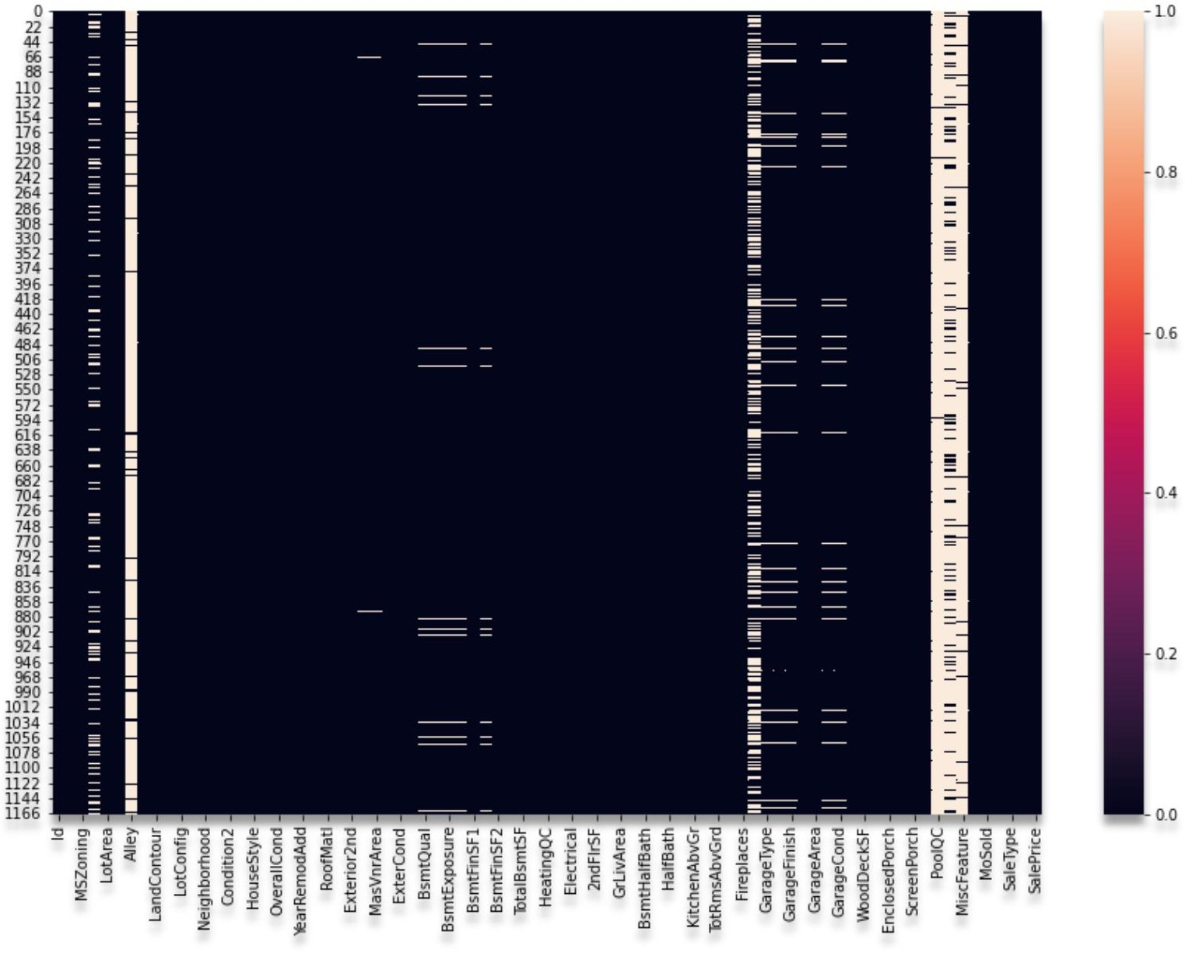

**Heatmap to show the null values of Train Dataset**

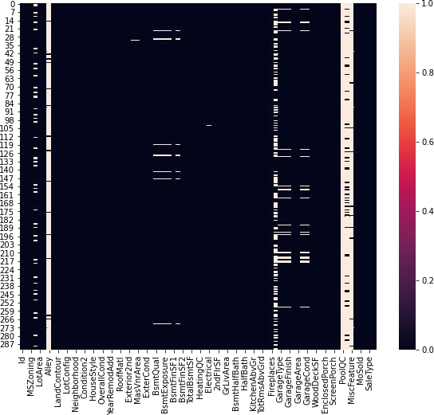

**Heatmap to show the null values of Test Dataset.**

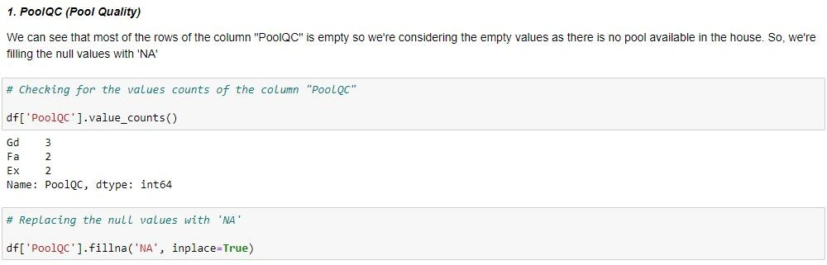

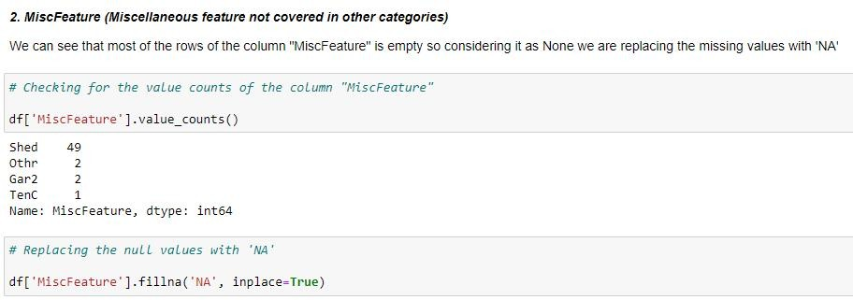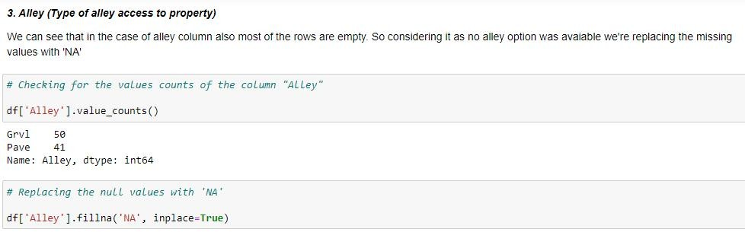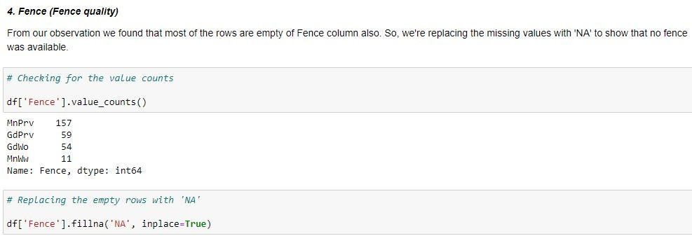

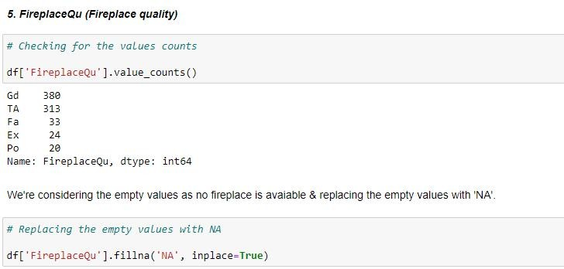

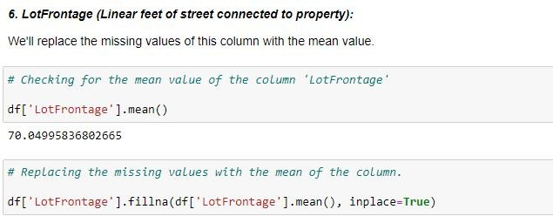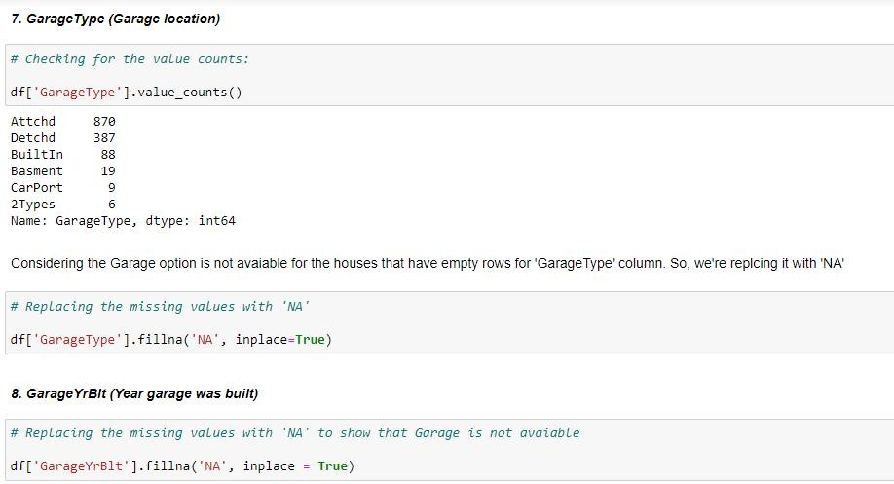

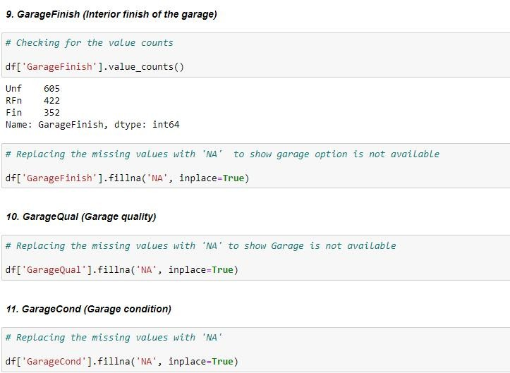

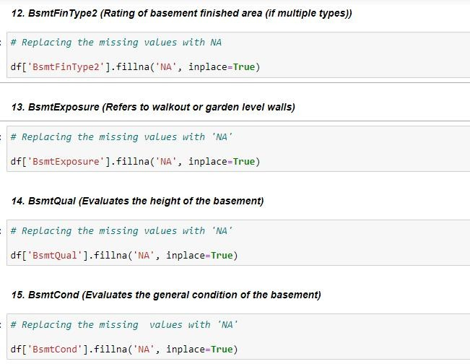

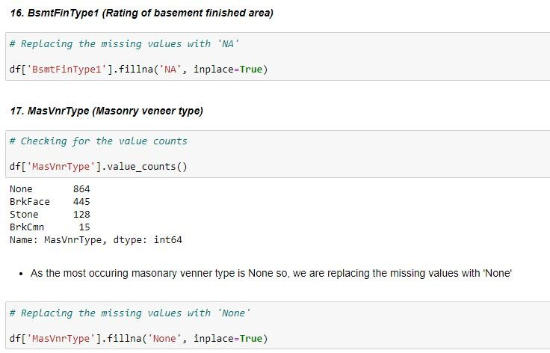

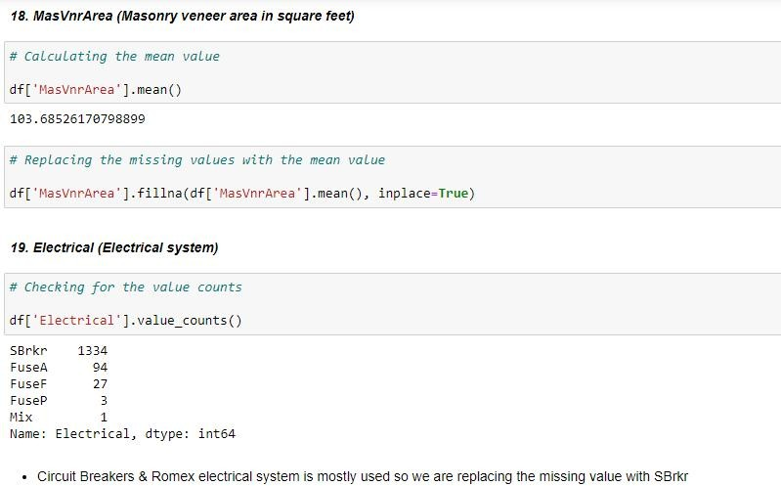

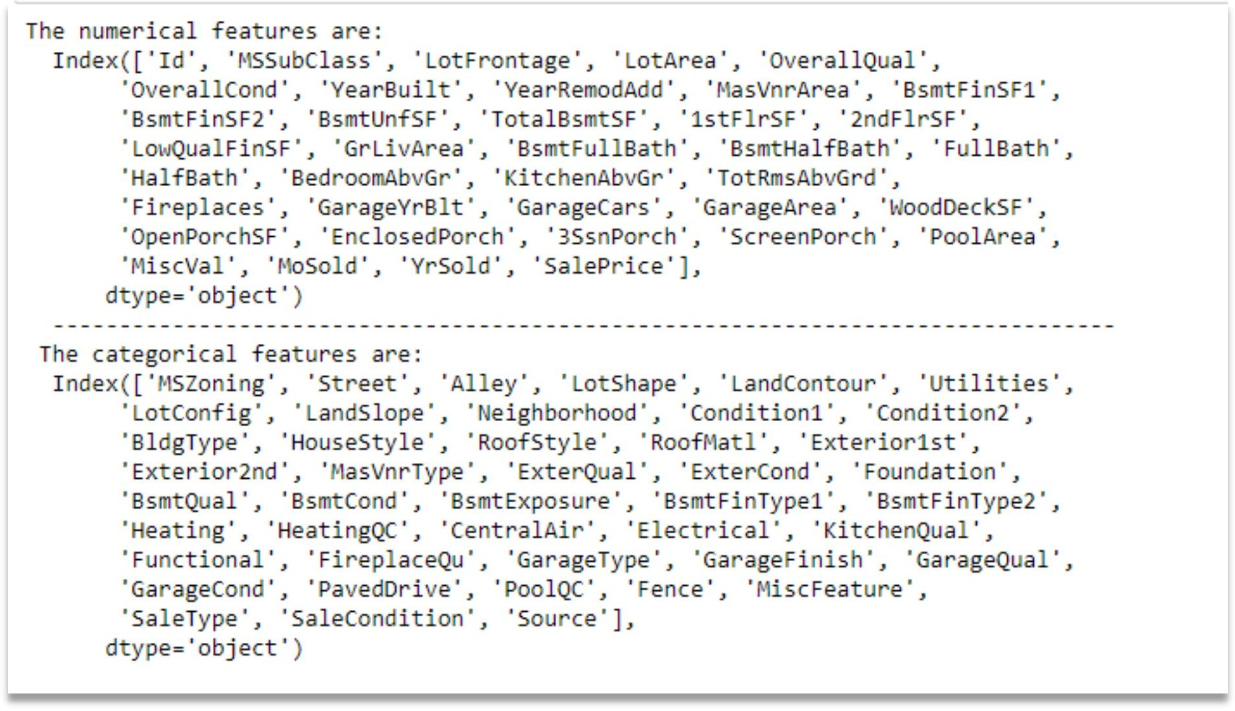

## Data Inputs- Logic- Output Relationships

EDA was performed by creating valuable insights using various visualization libraries.

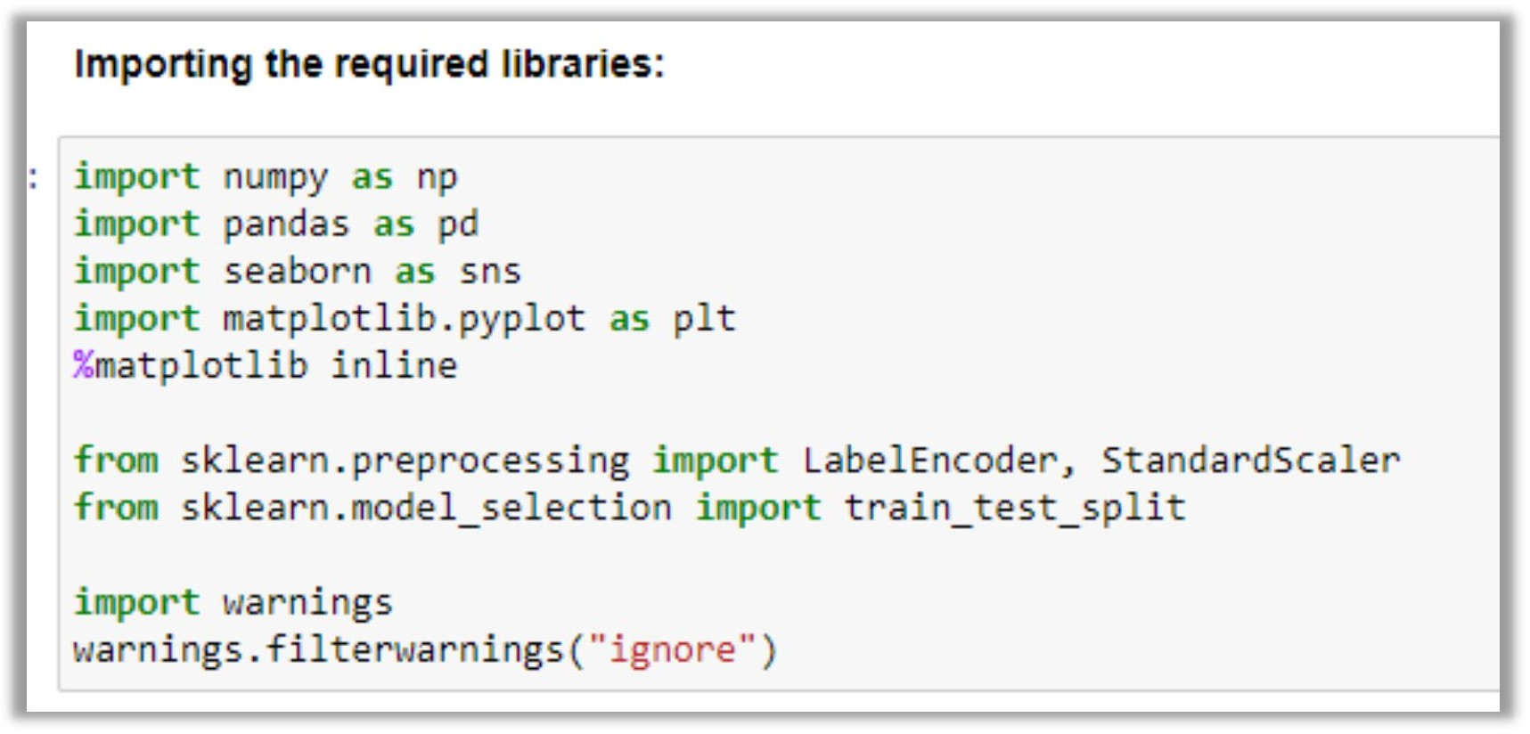

**Software & Tools:**

1. Jupyter Notebook
2. Python
3. Pandas
4. Numpy
5. Matplotlib (used for visualization)
6. Seaborn (used for visualization)
7. Scikit-learn (used as algorithmic libraries)

# Development and Evaluation

## Methods:

* Performed EDA (Exploratory Data Analysis).
* Data Cleaning and dropping the columns which were not contributing to the dataset.
* Handled the missing values.
* Checked for the outliers and tried to remove the outliers of the dataset.
* Checked for the skewness in the dataset and removed the skewness for better model building.
* Train- Test the dataset into independent and dependent variables.
* Model Building.

## Testing of Identified Approaches (Algorithms)

Below are the algorithms used for the training and testing:

* 1. Linear Regression.
  2. Lasso
  3. Decision Tree Regression.
  4. K Neighbour Regression.
  5. Random Forest Regression.

## Evaluating selected models:

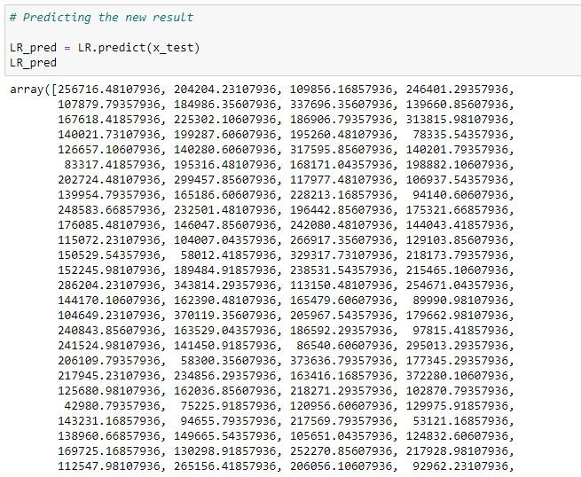

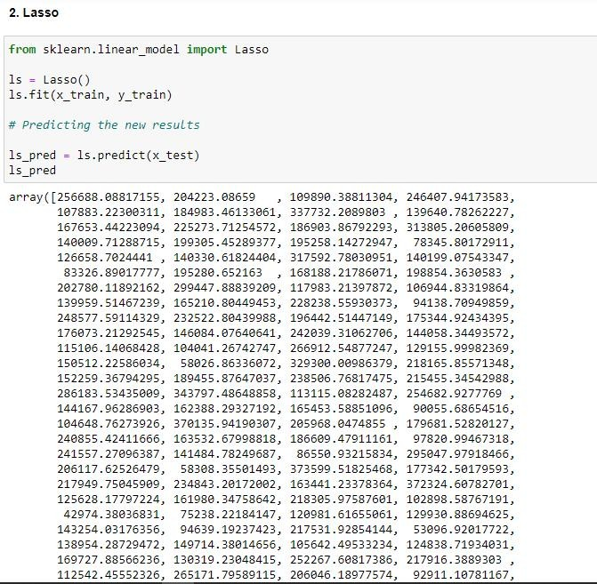

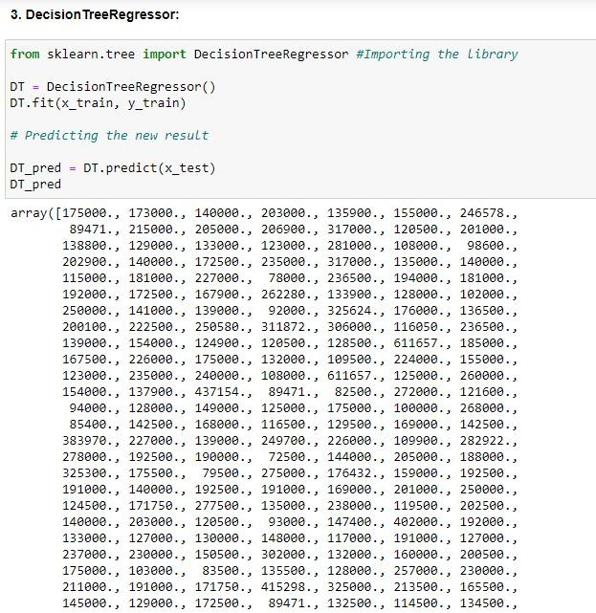

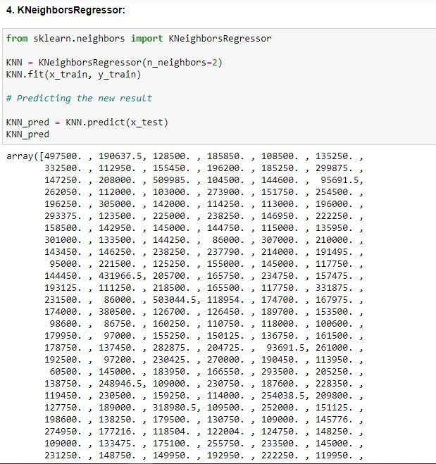

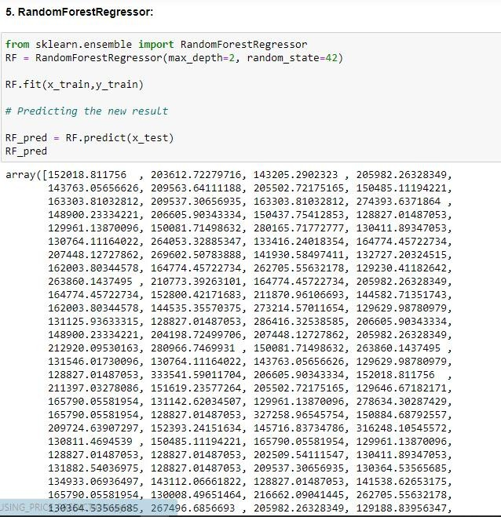

* Key Metrics for success in solving problem under consideration

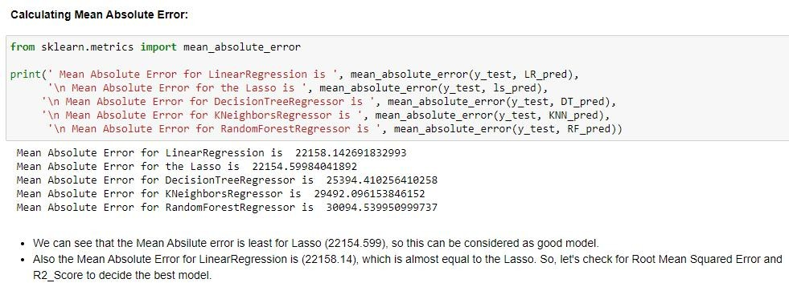

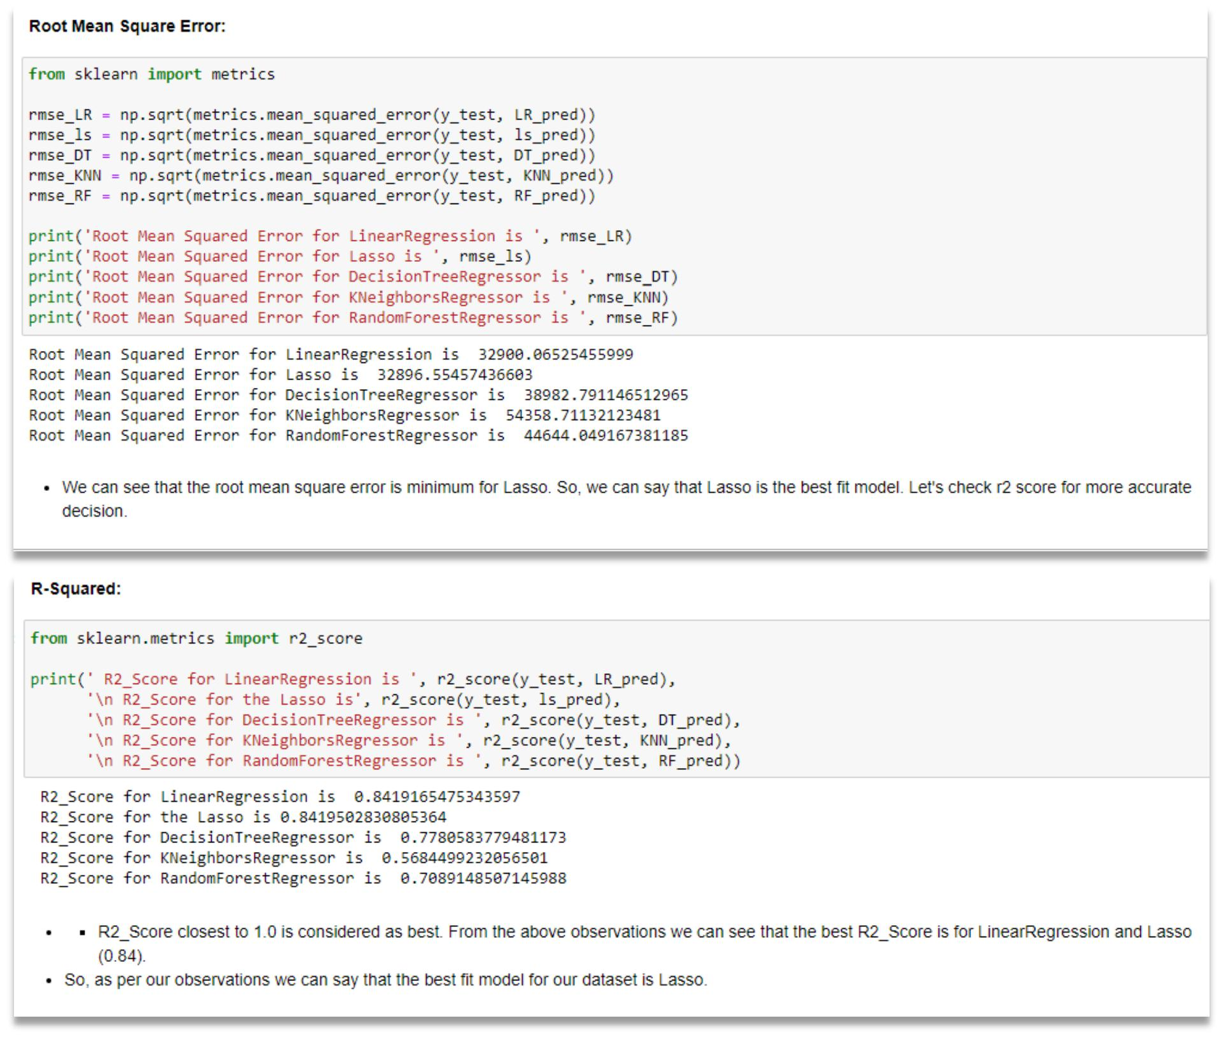

* Visualizations

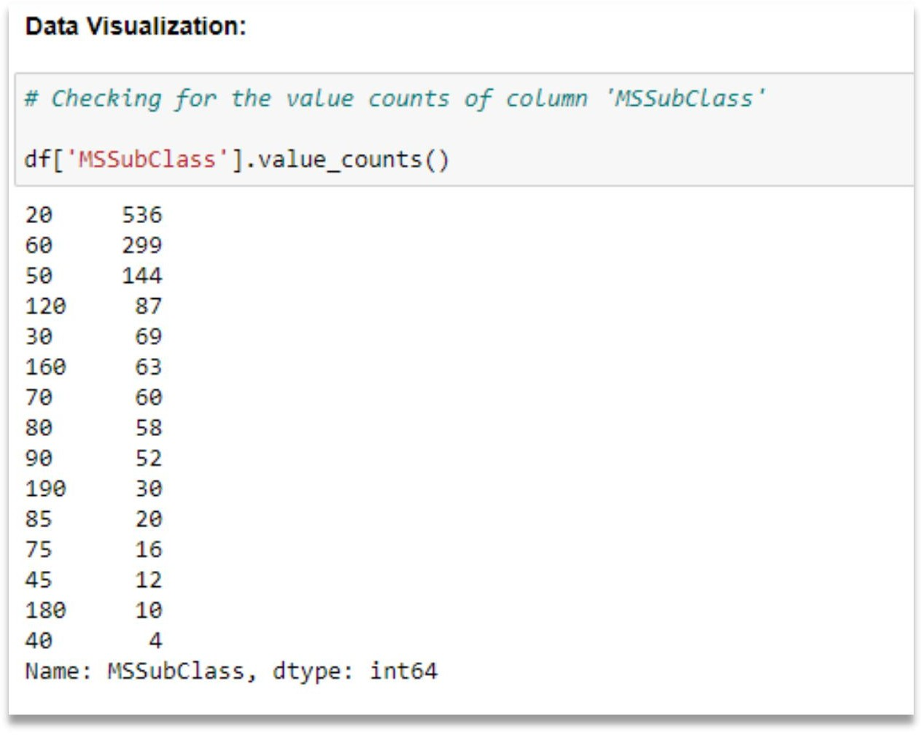

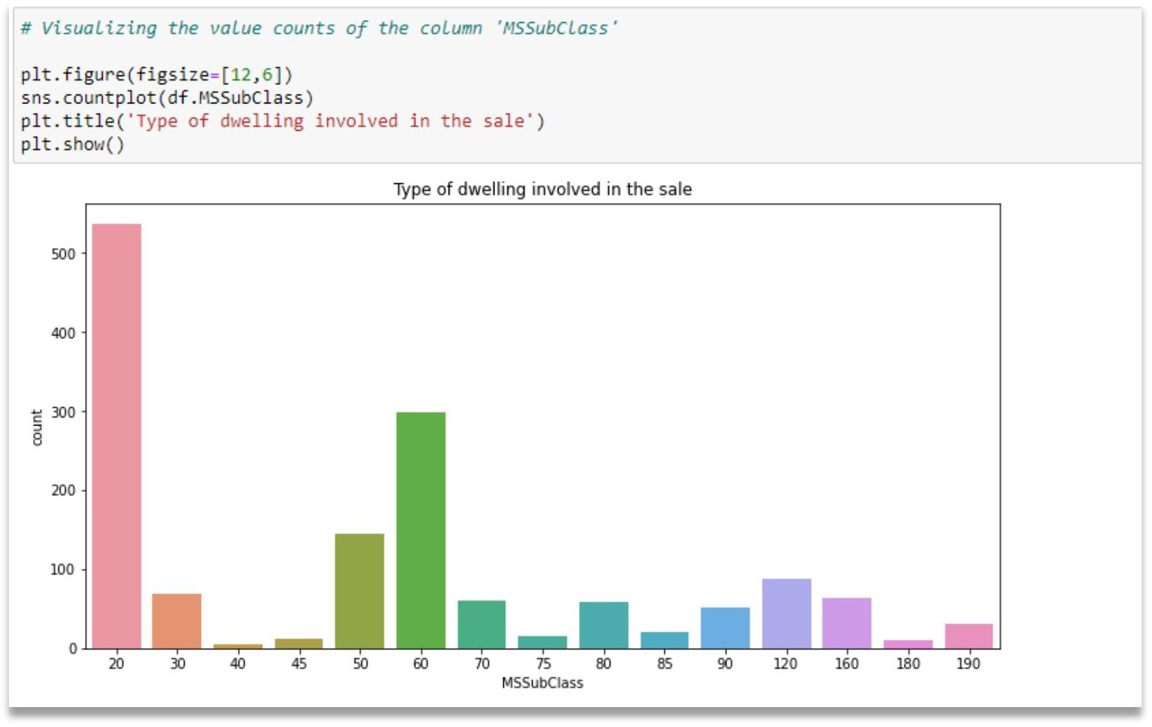

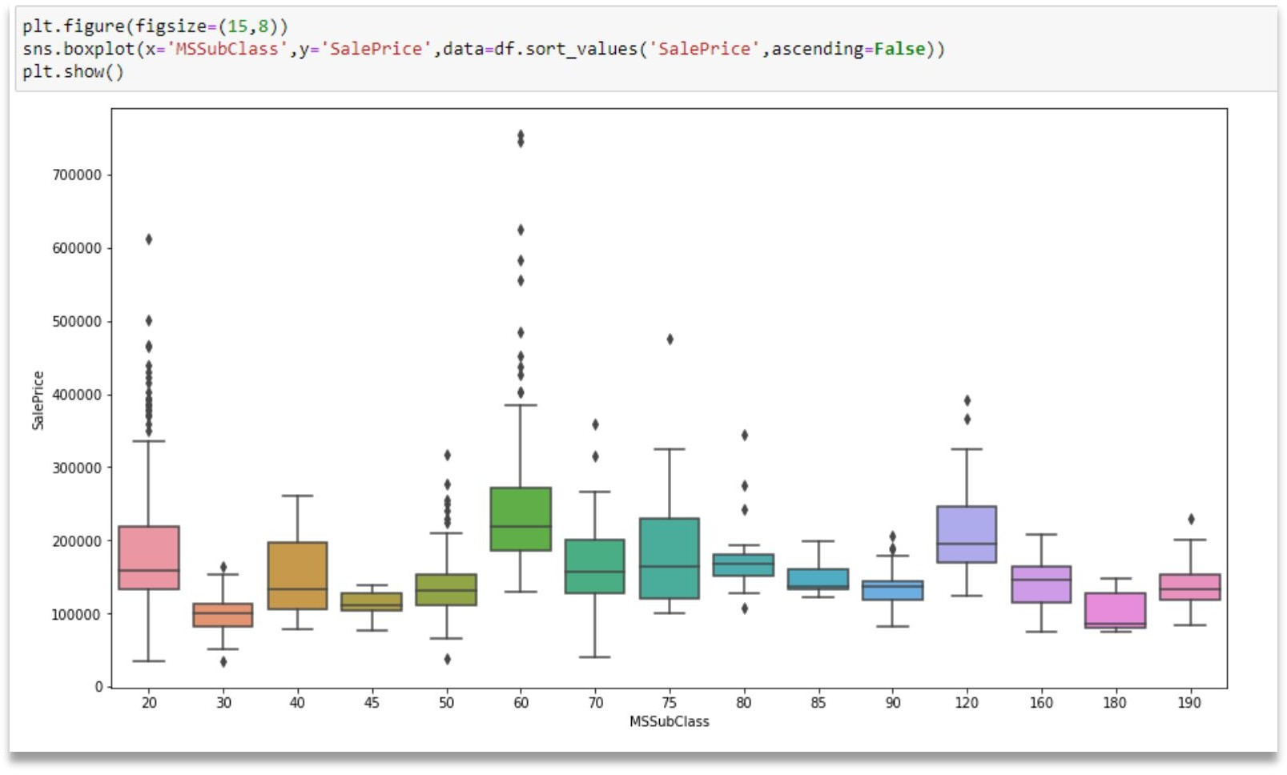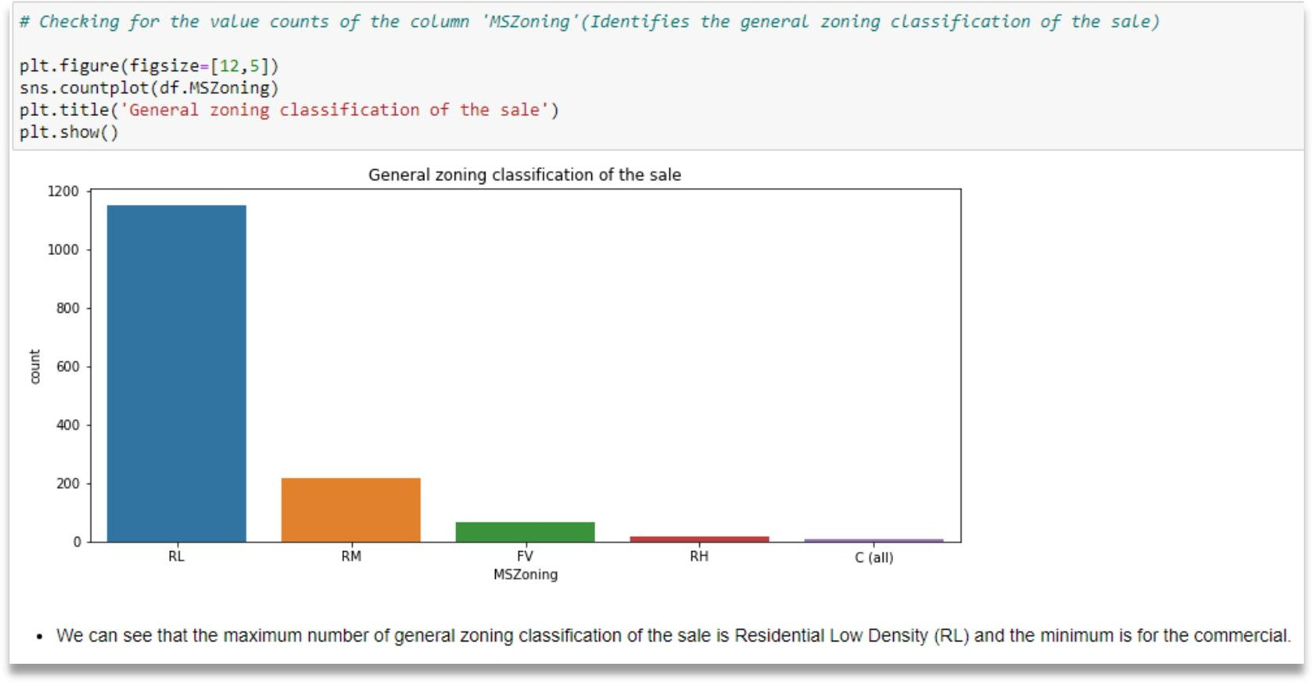

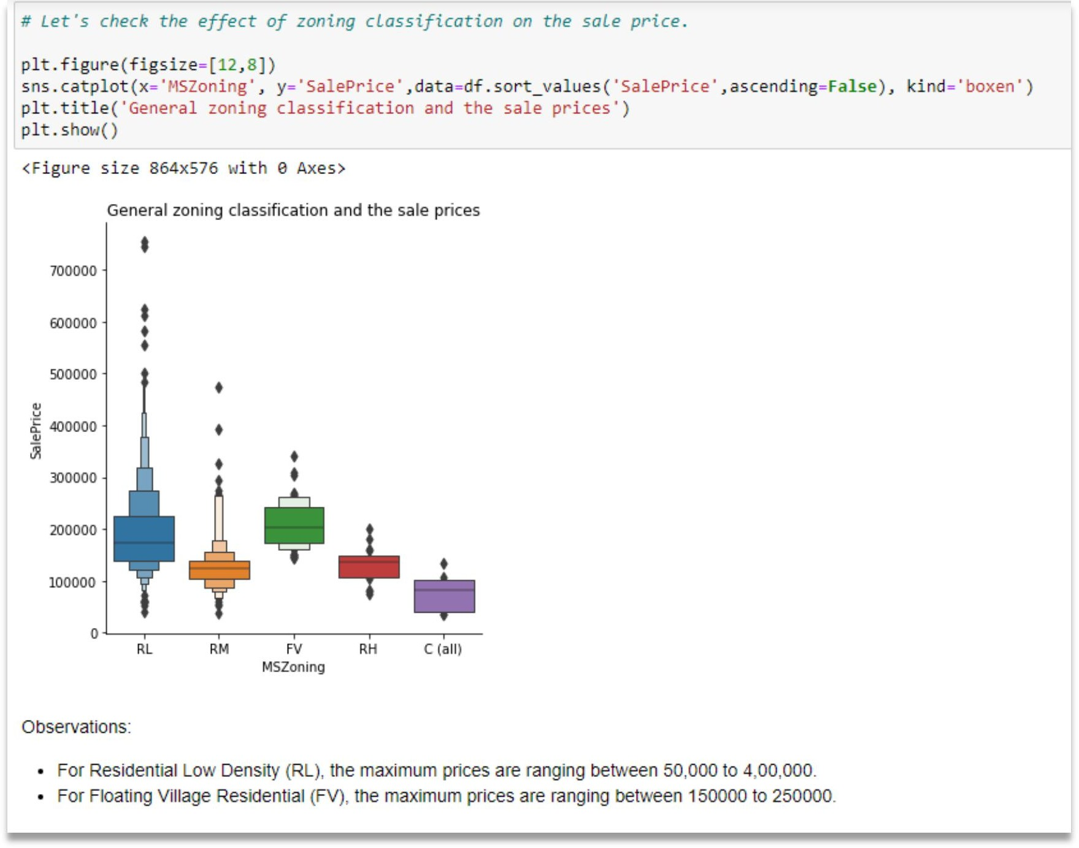

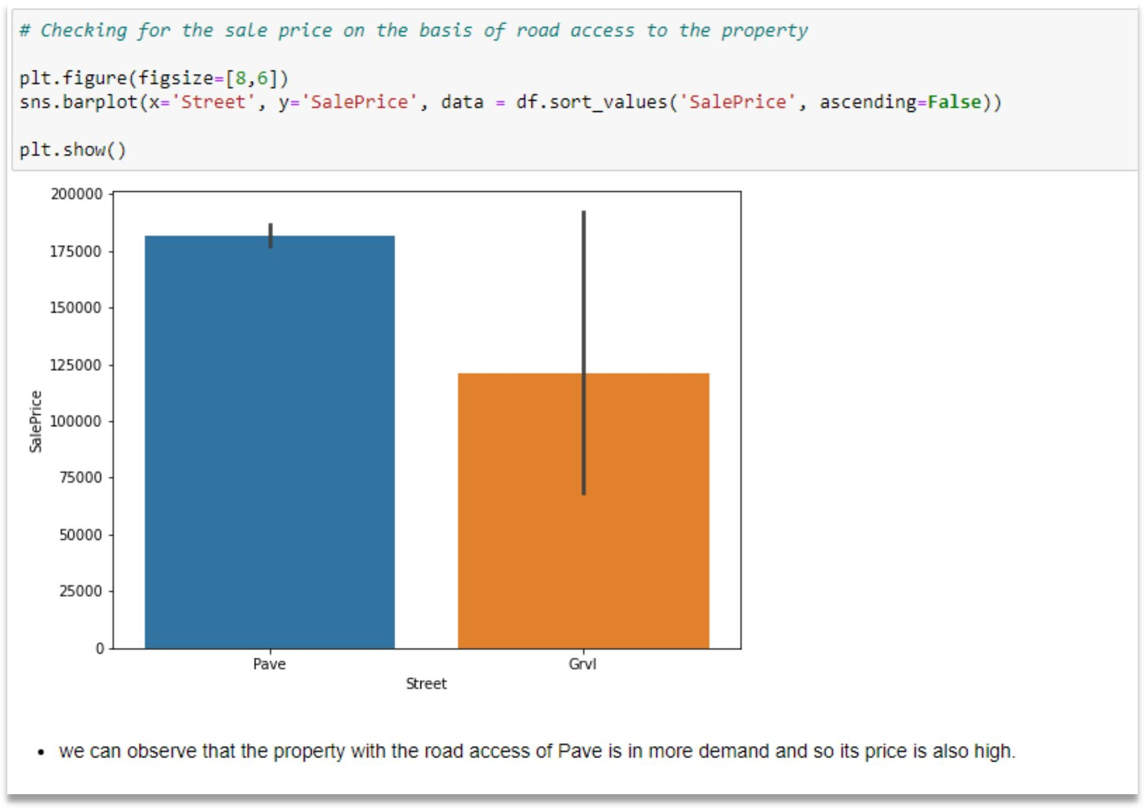

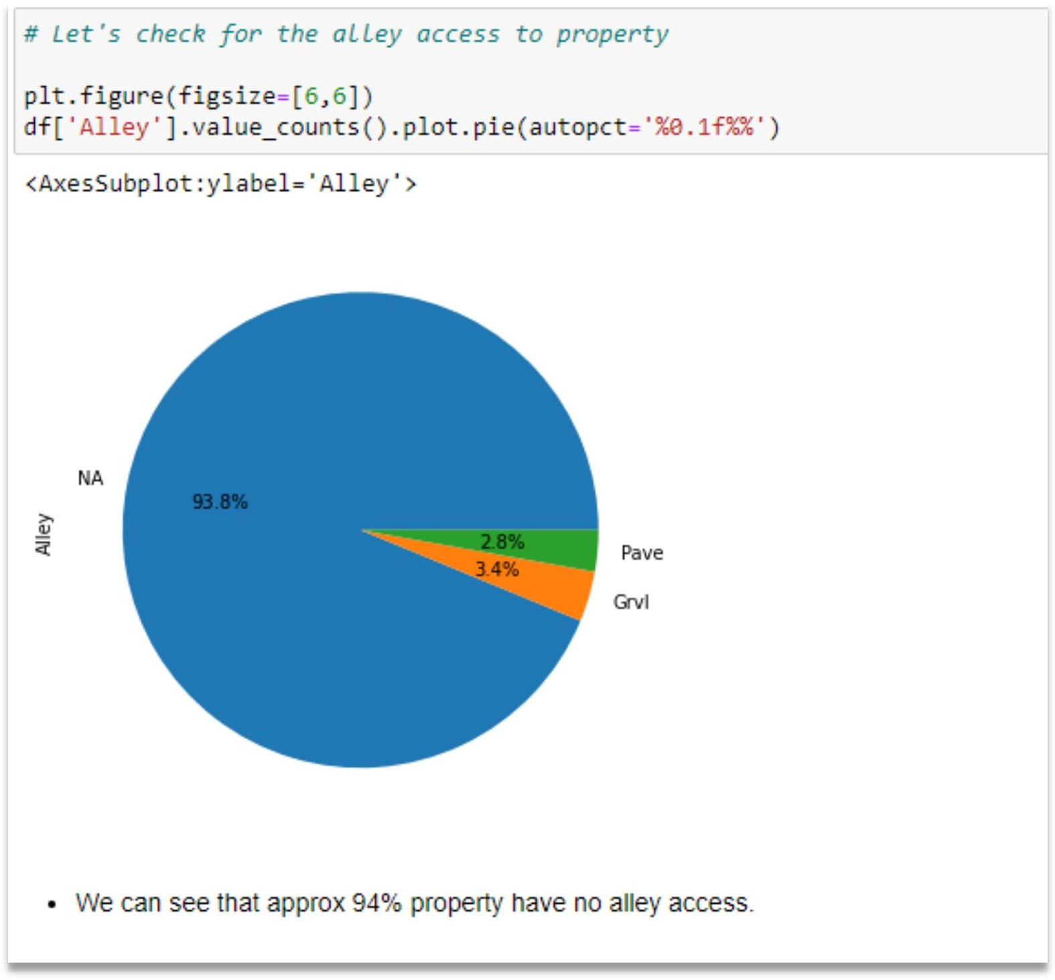

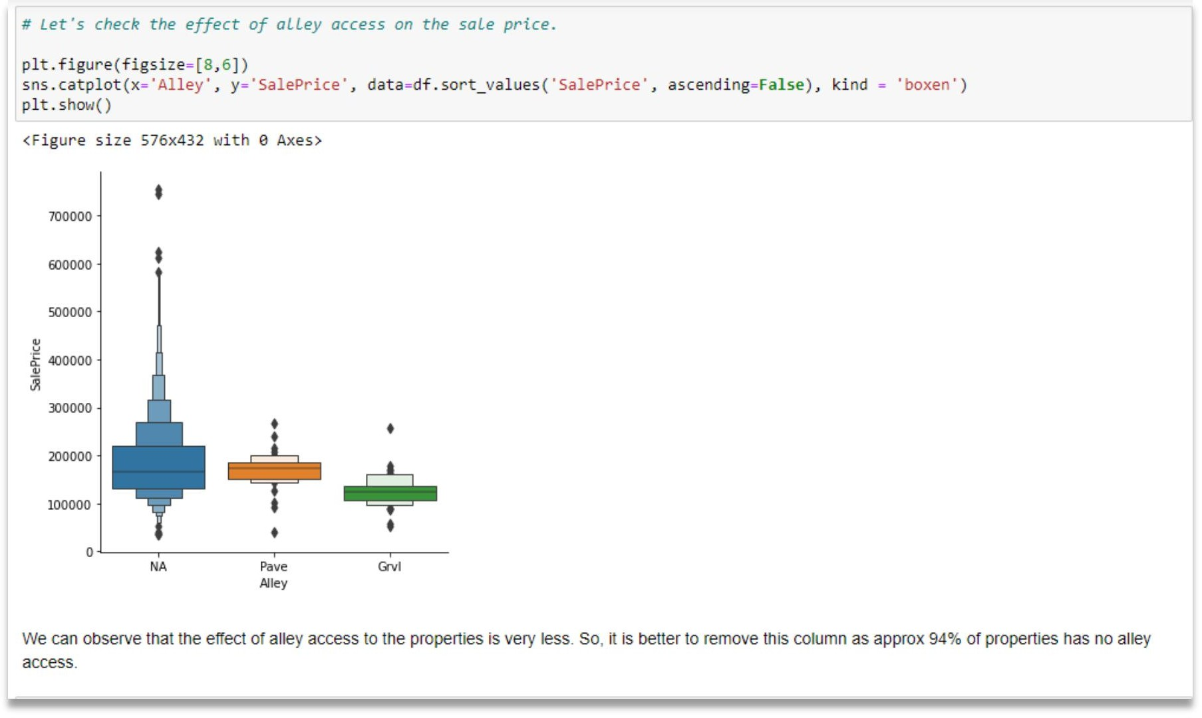

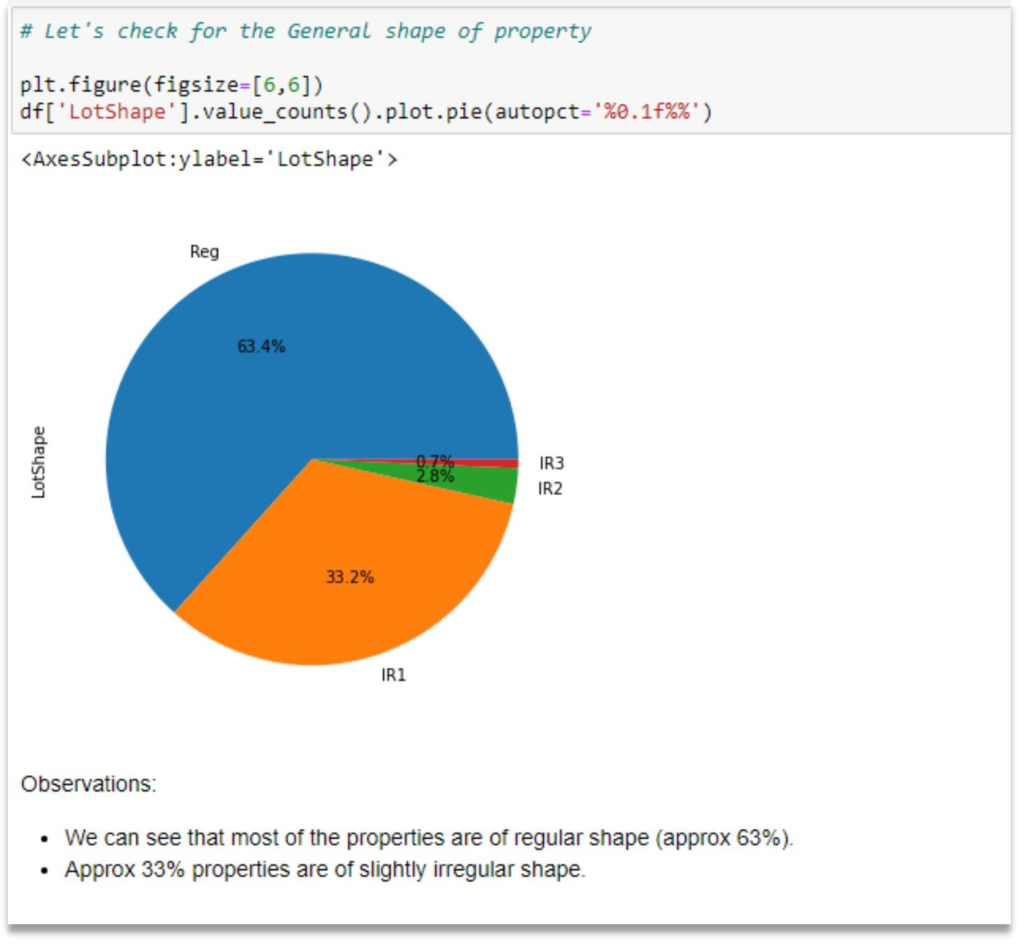

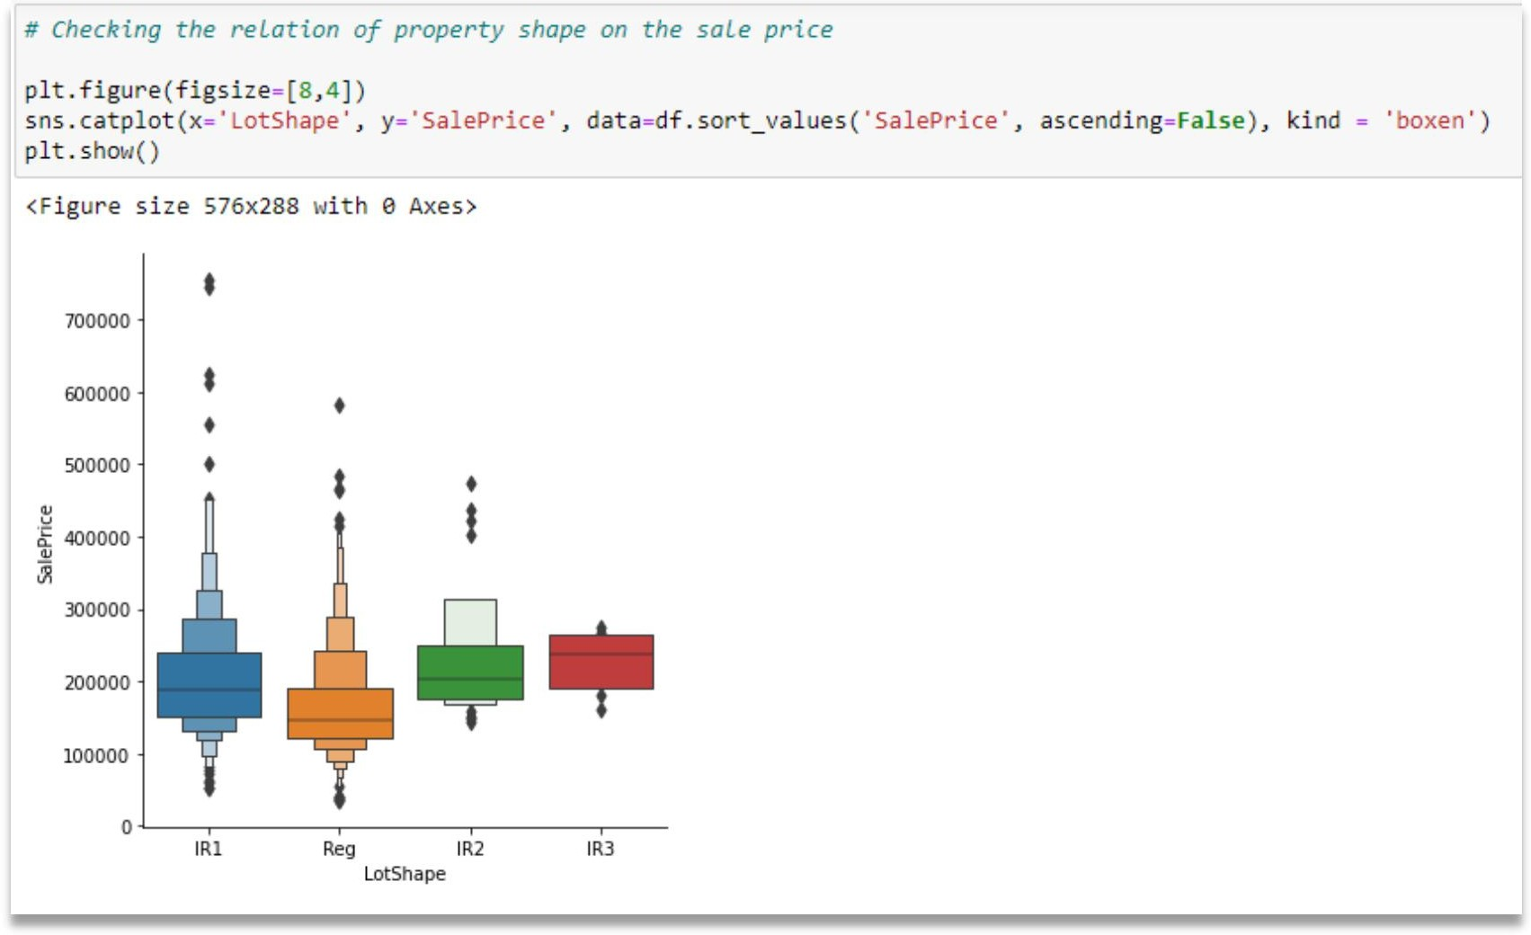

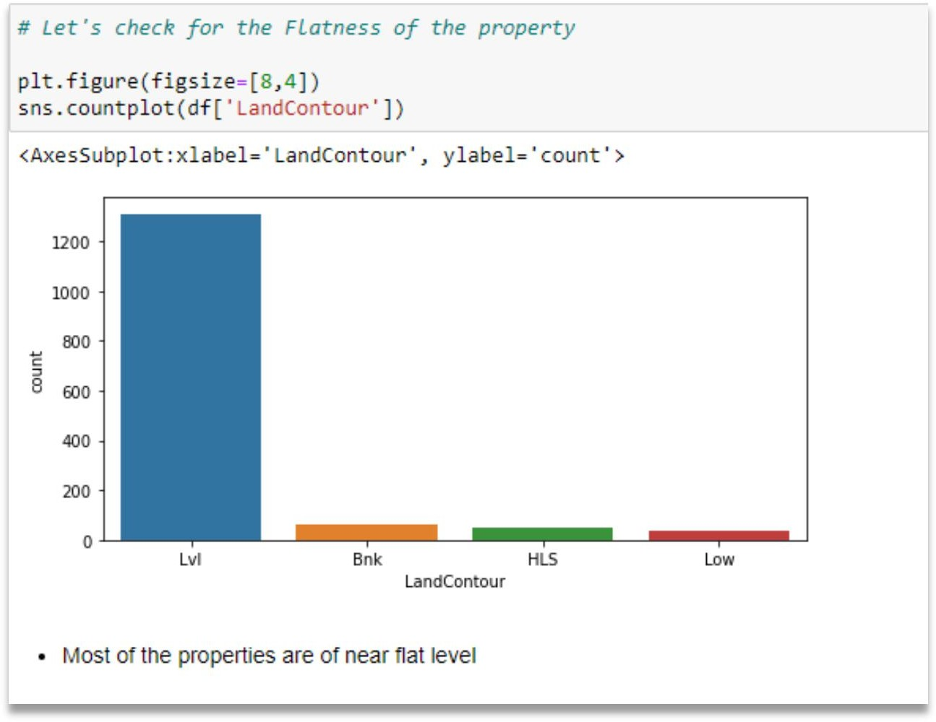

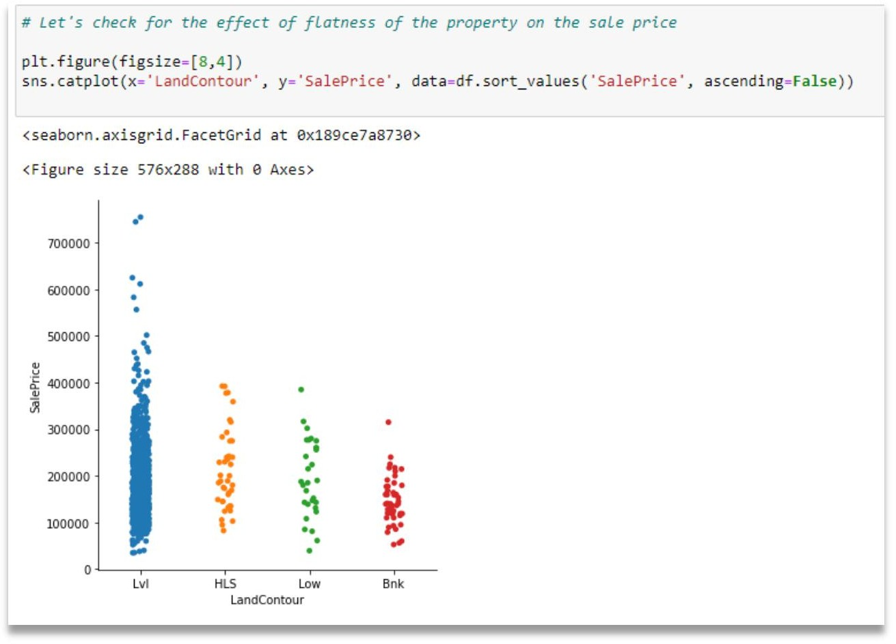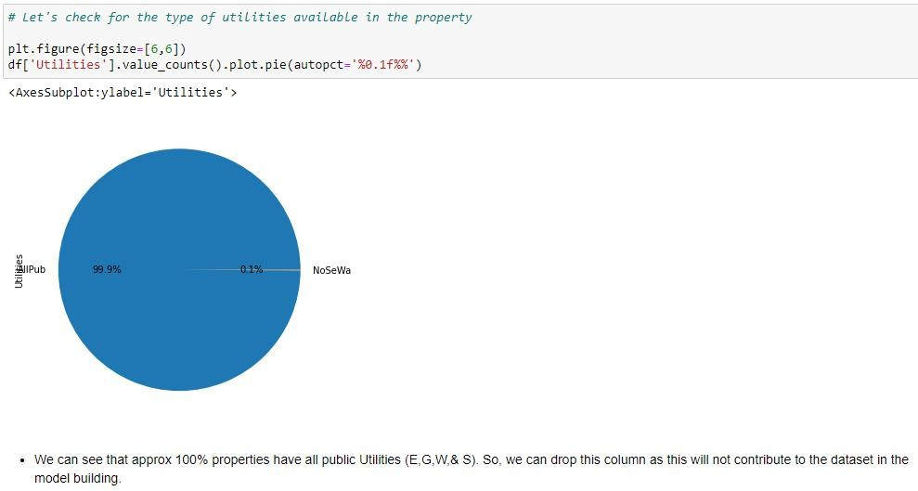

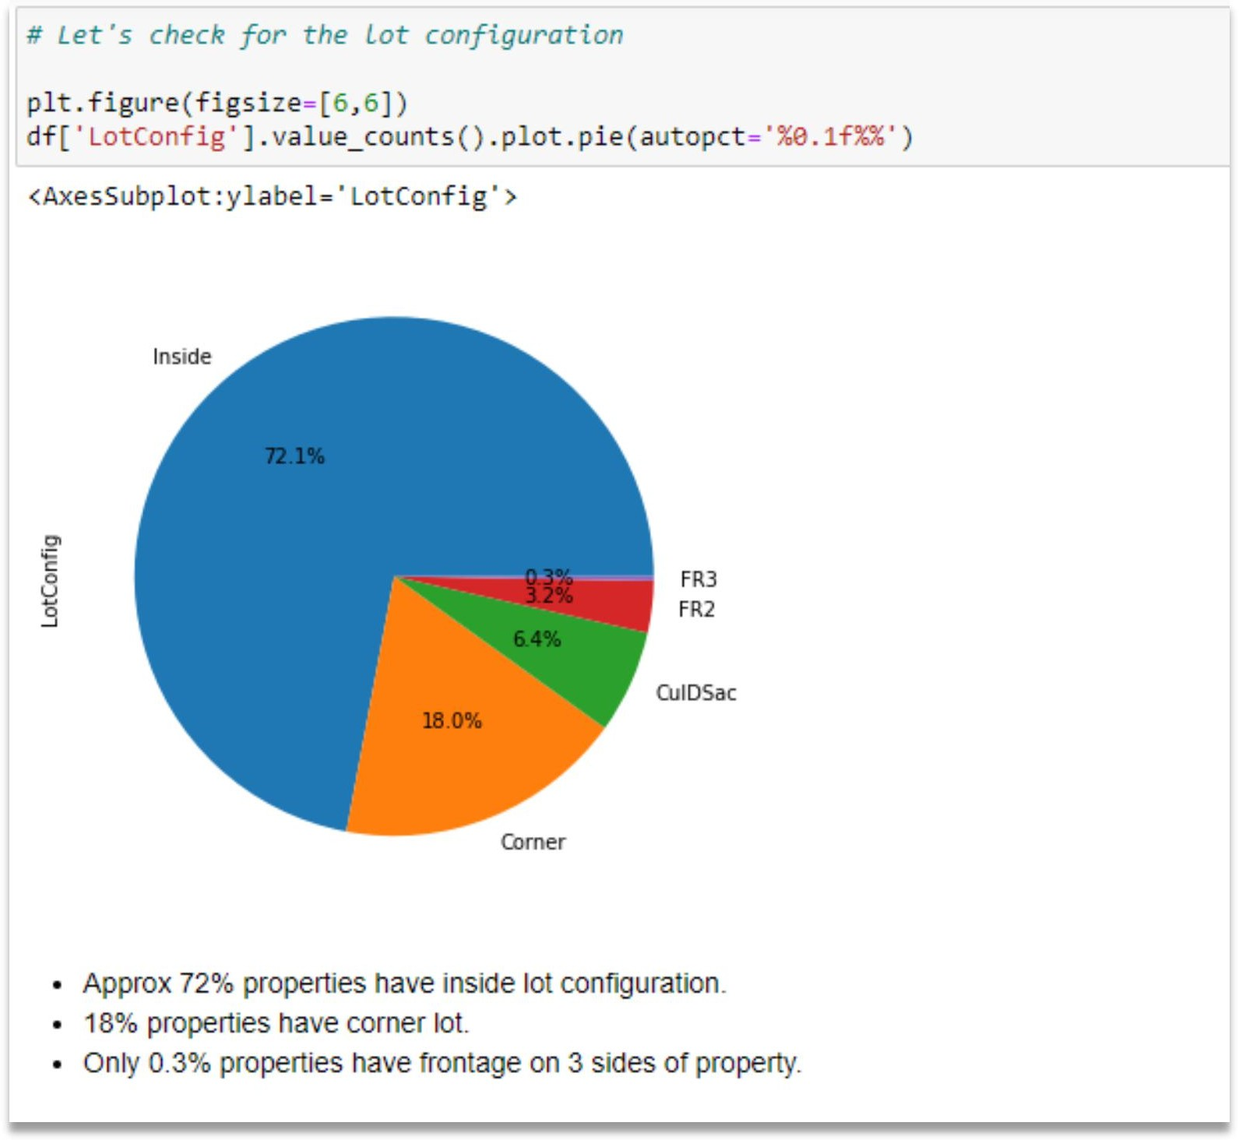

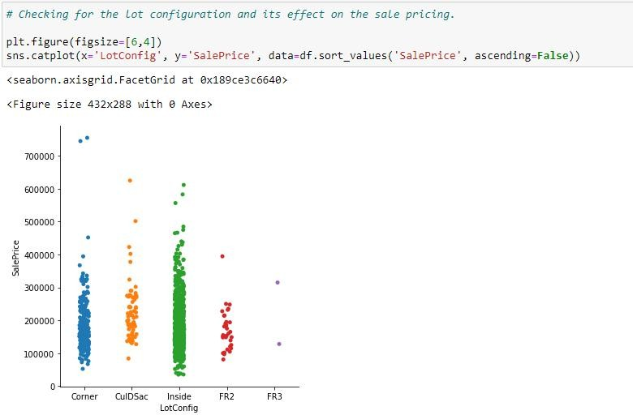

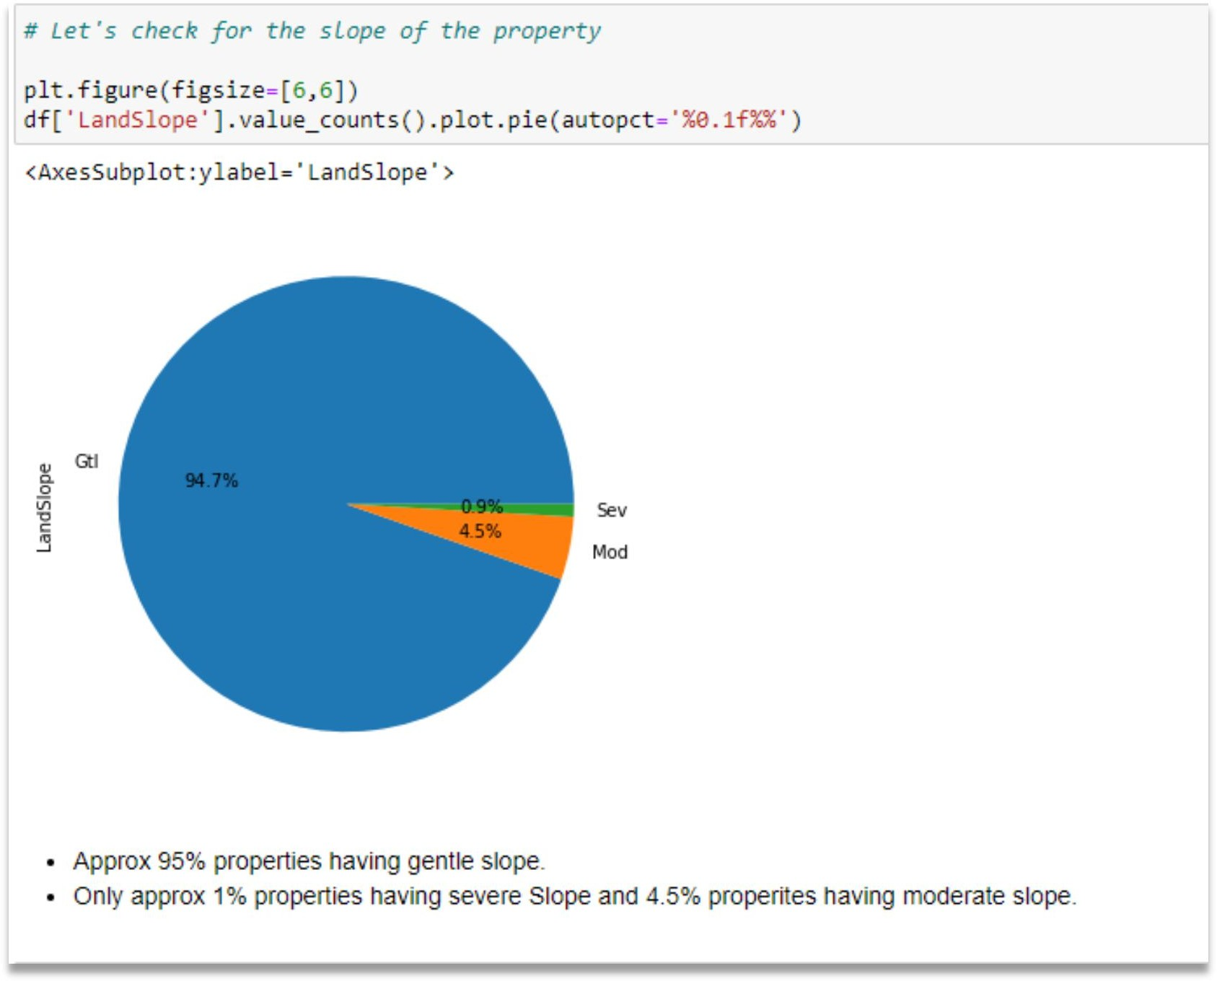

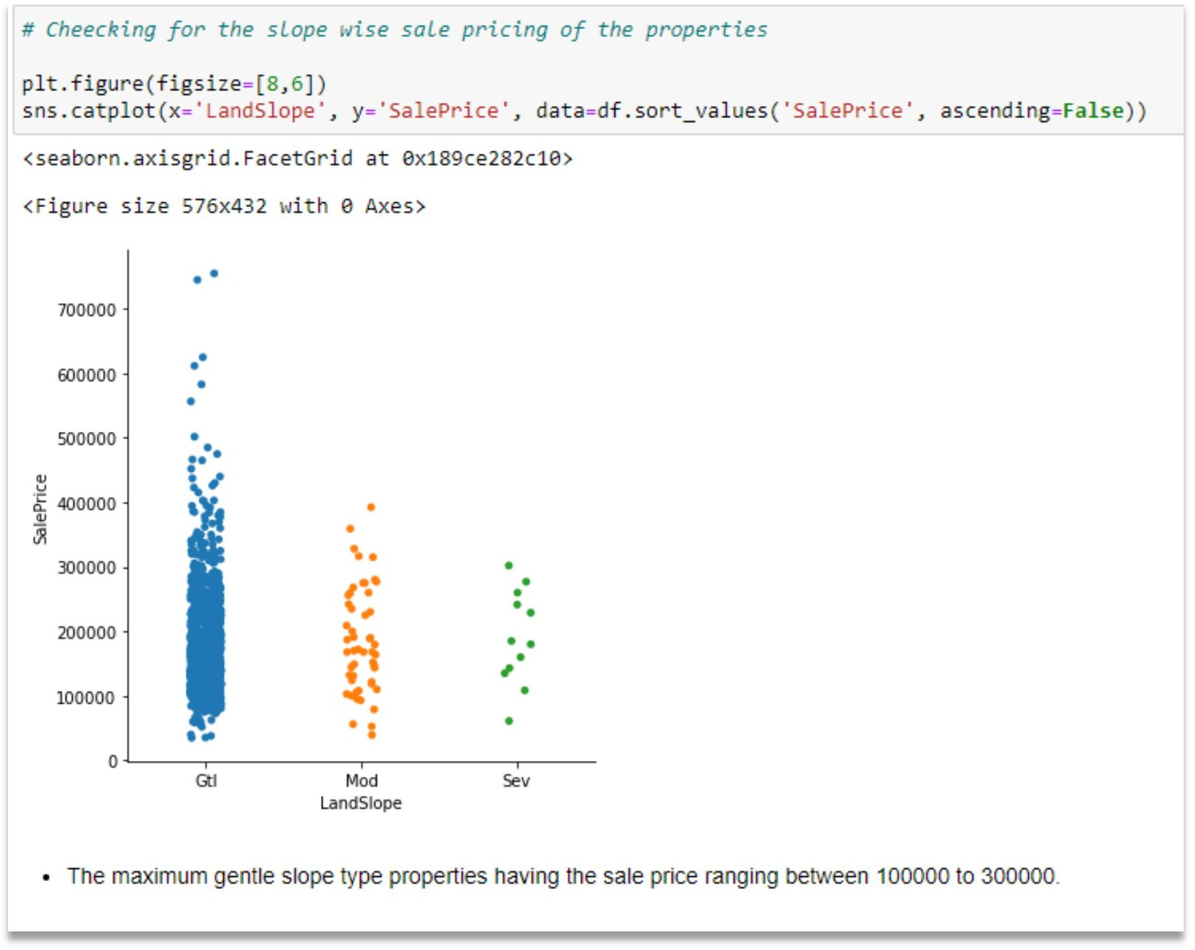

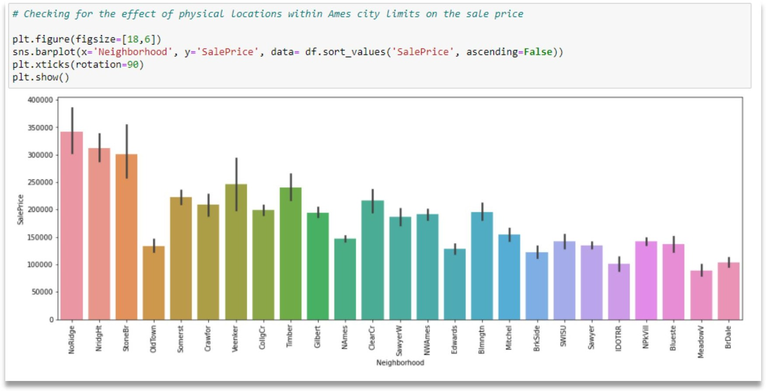

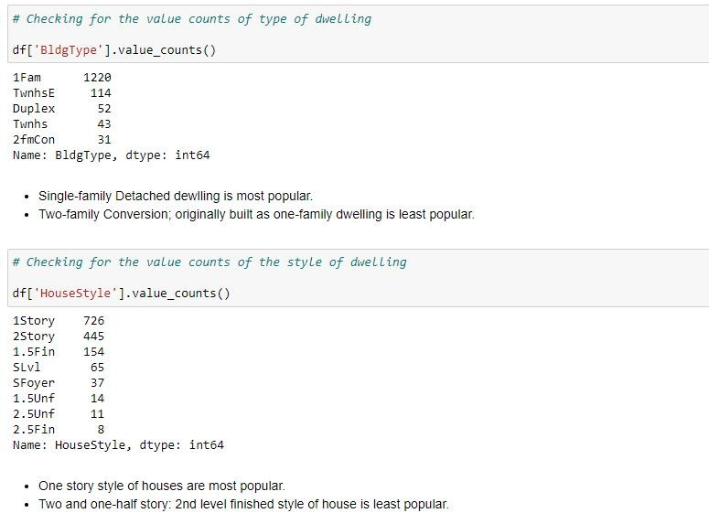

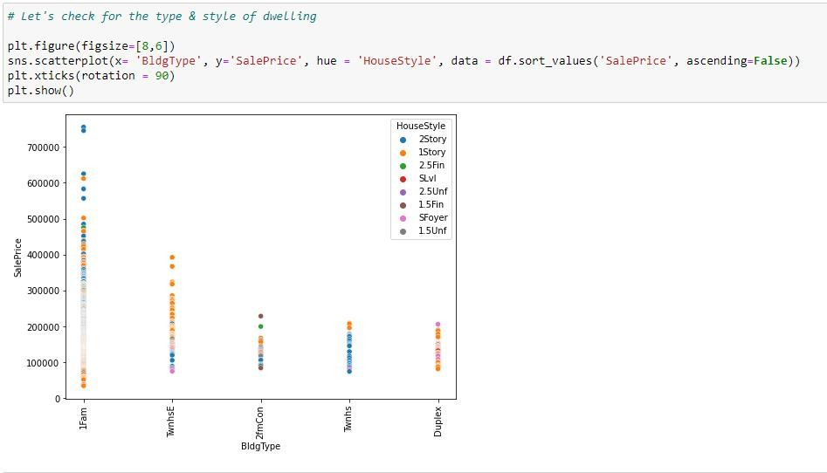

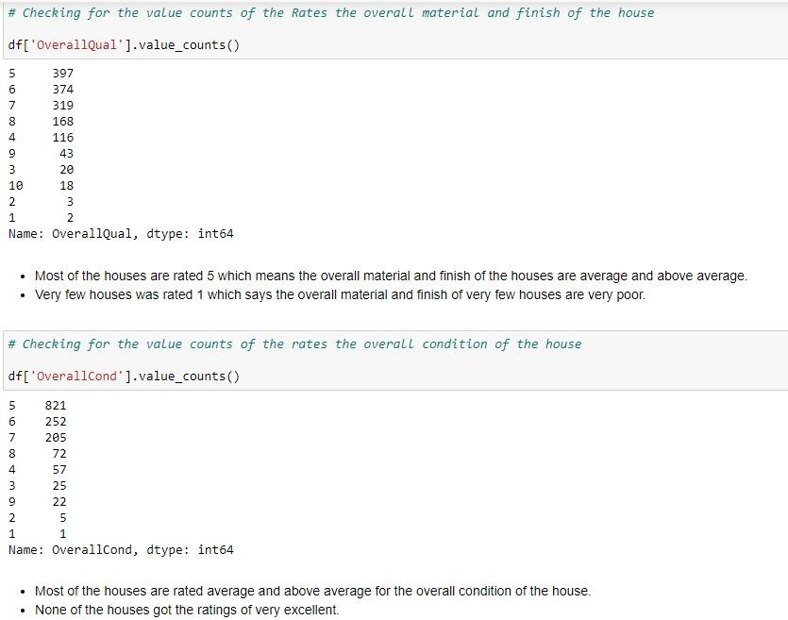

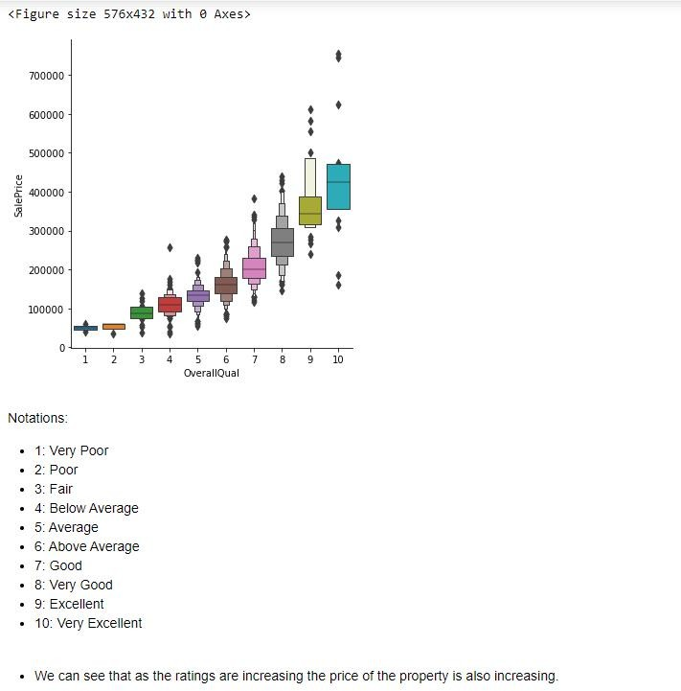

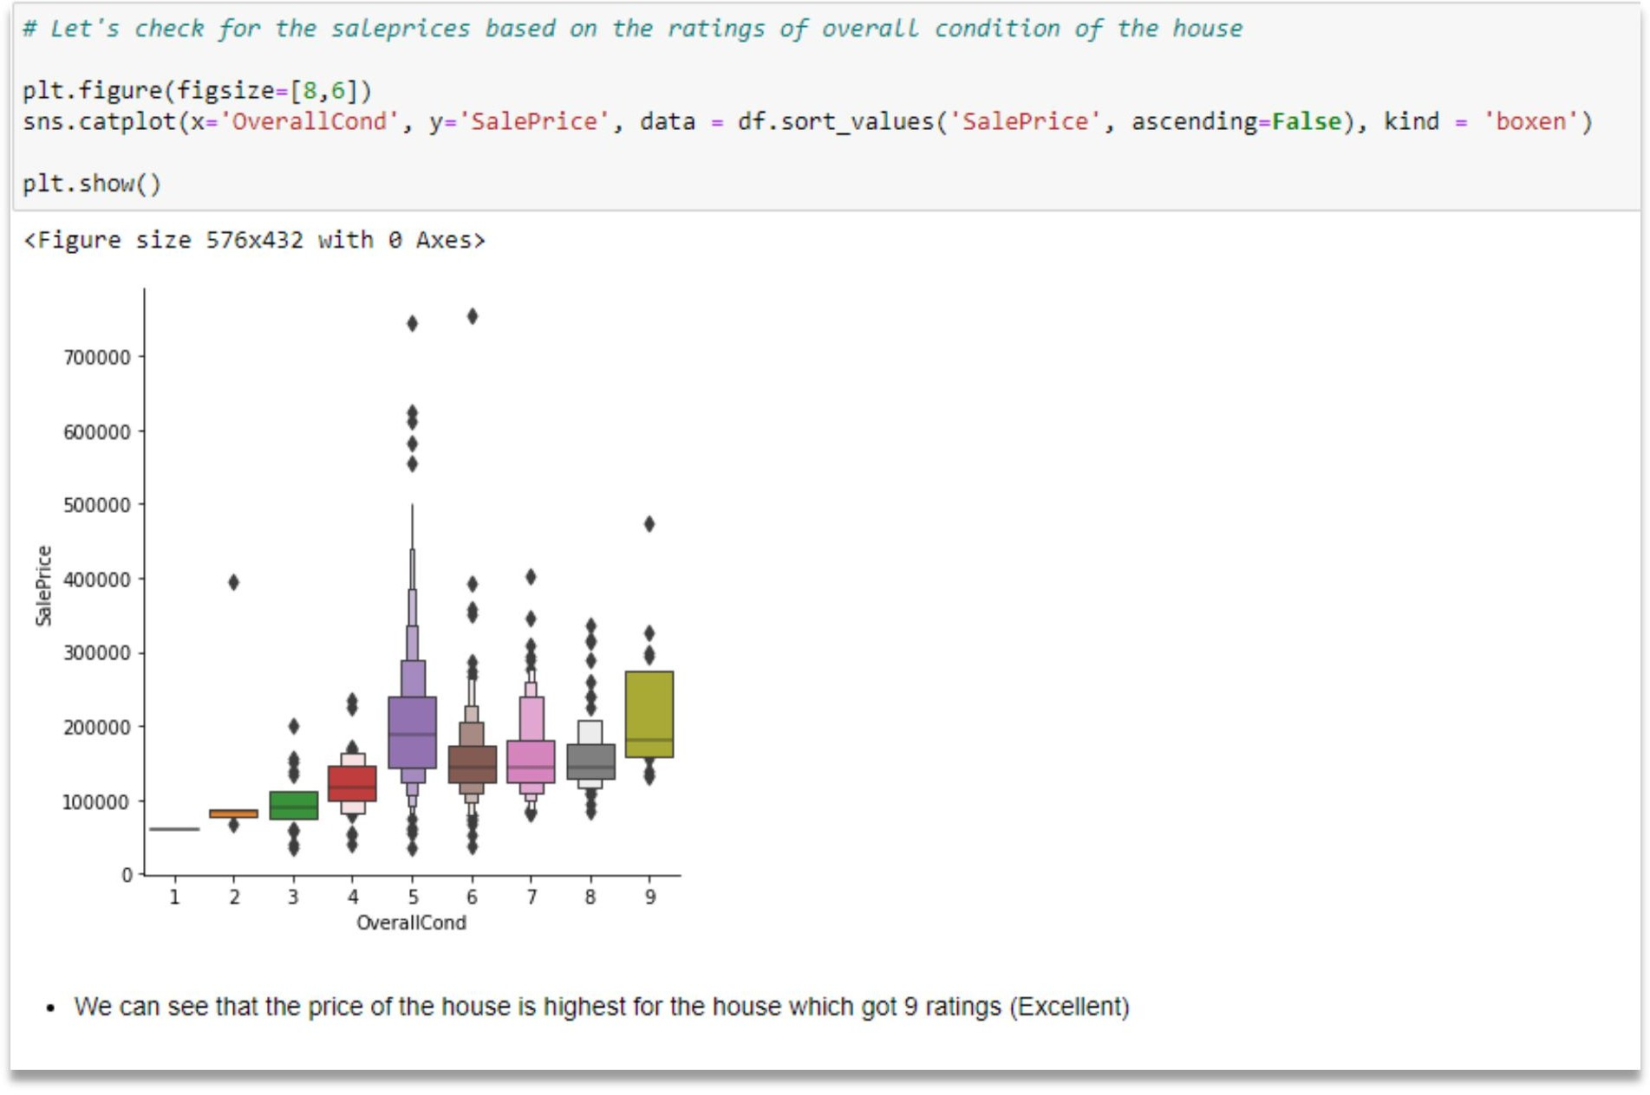

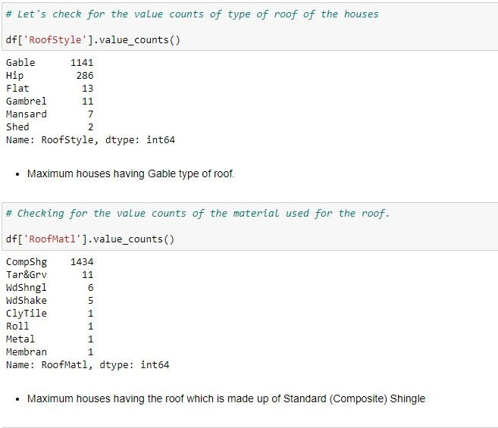

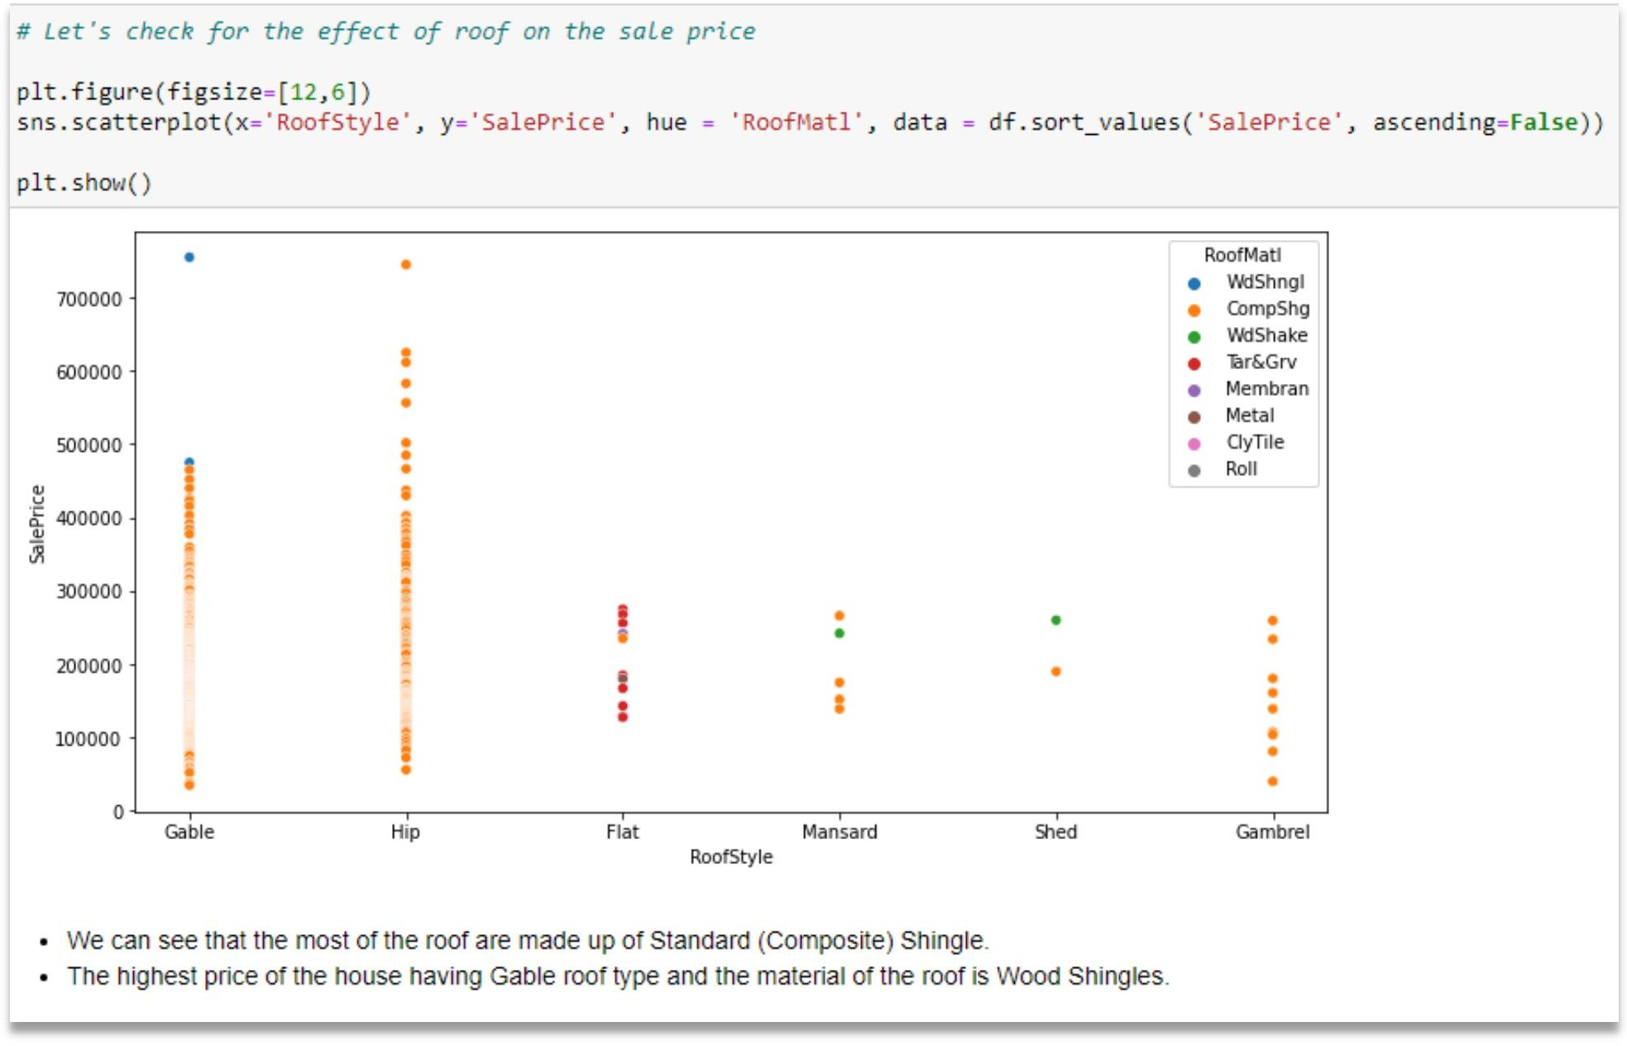

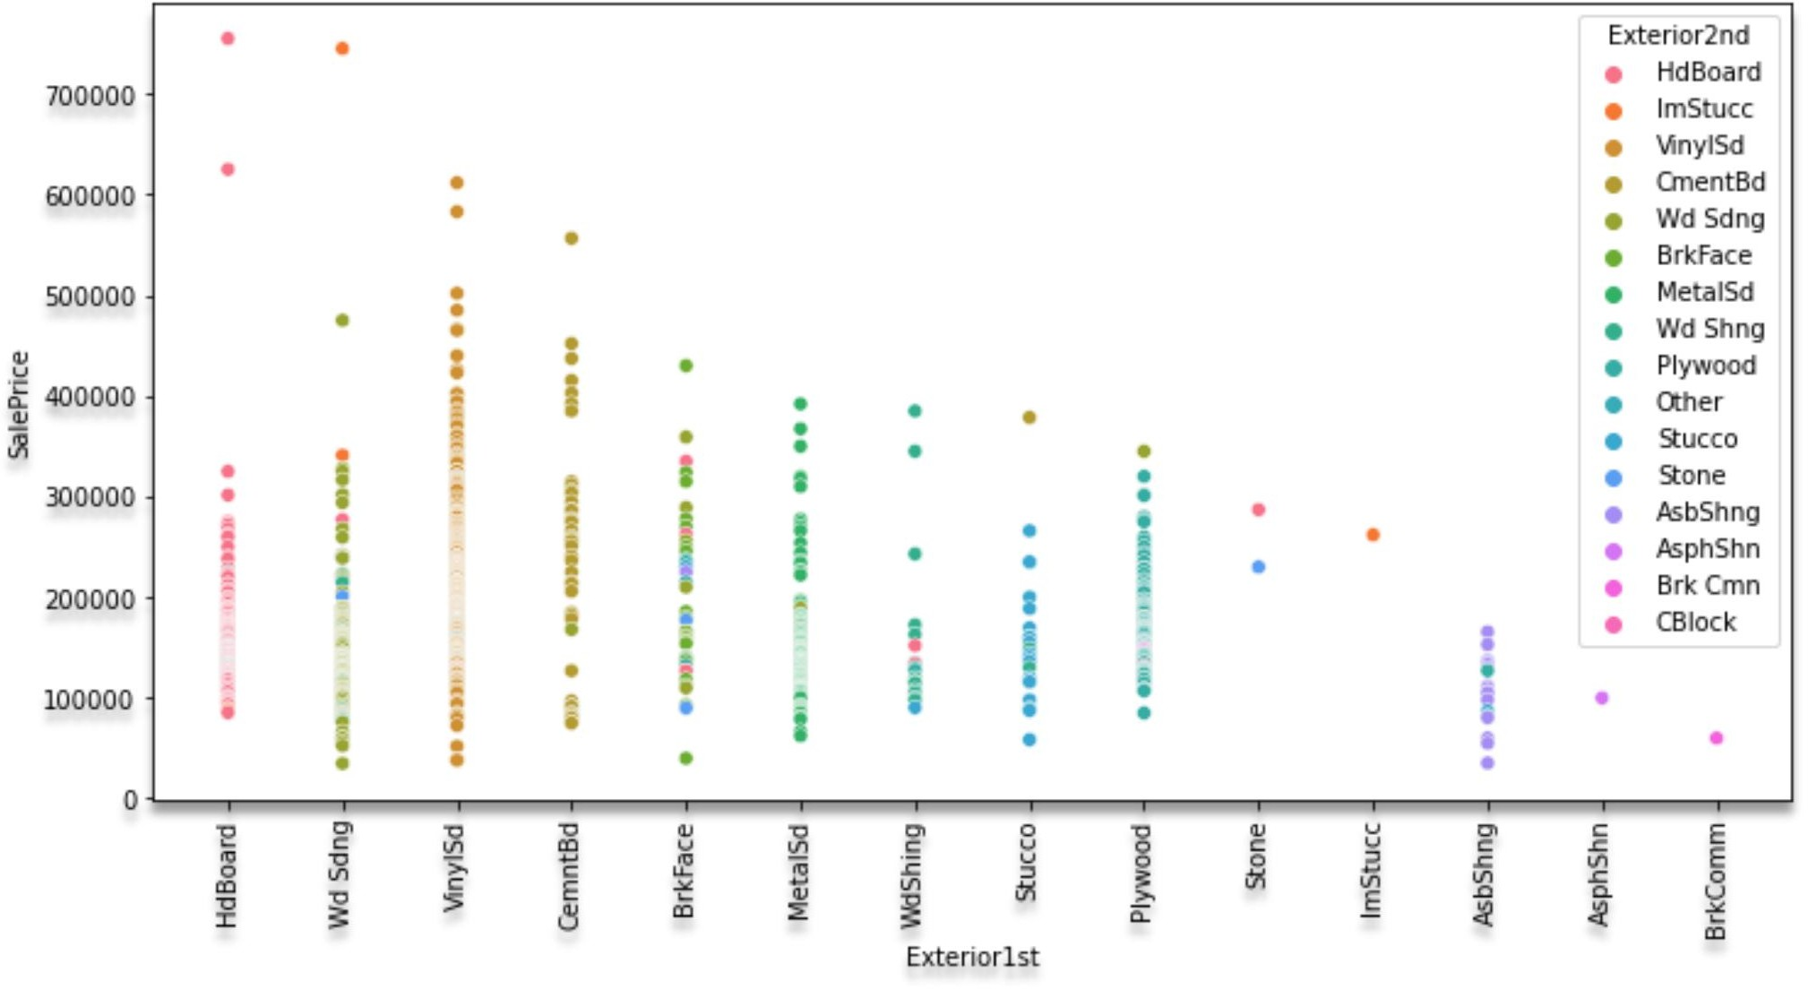

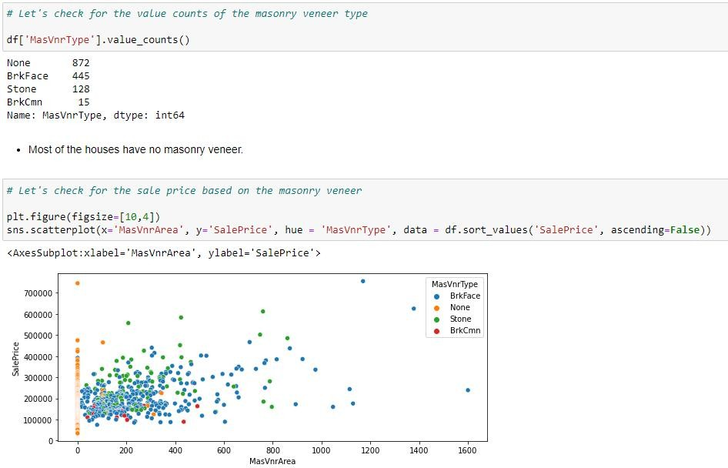

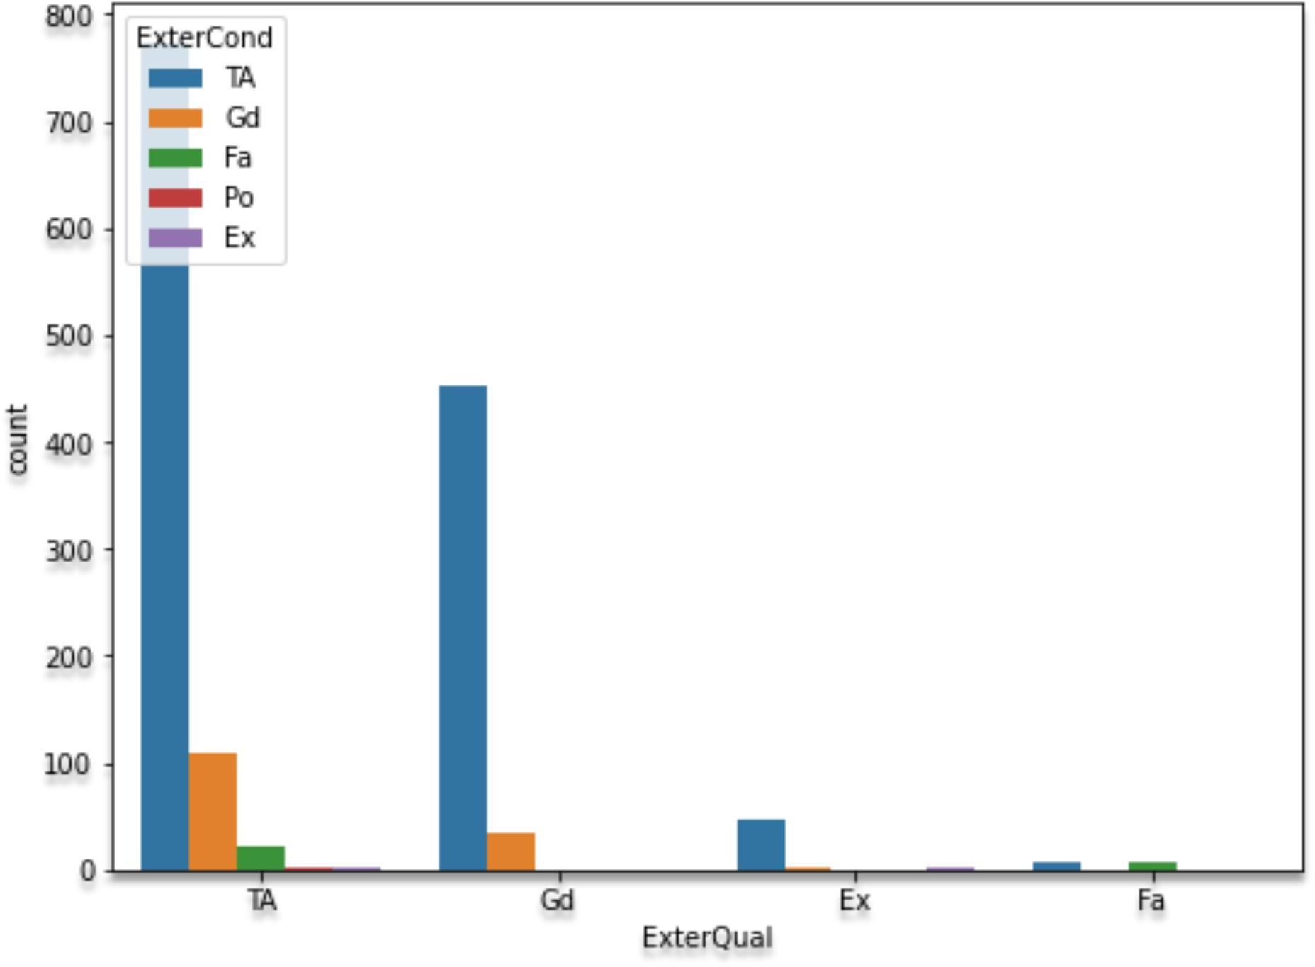

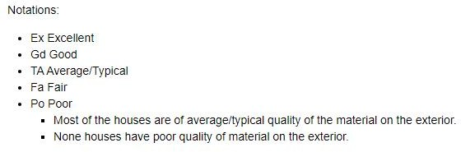

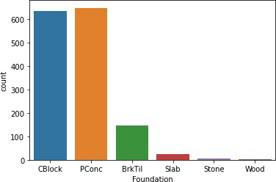

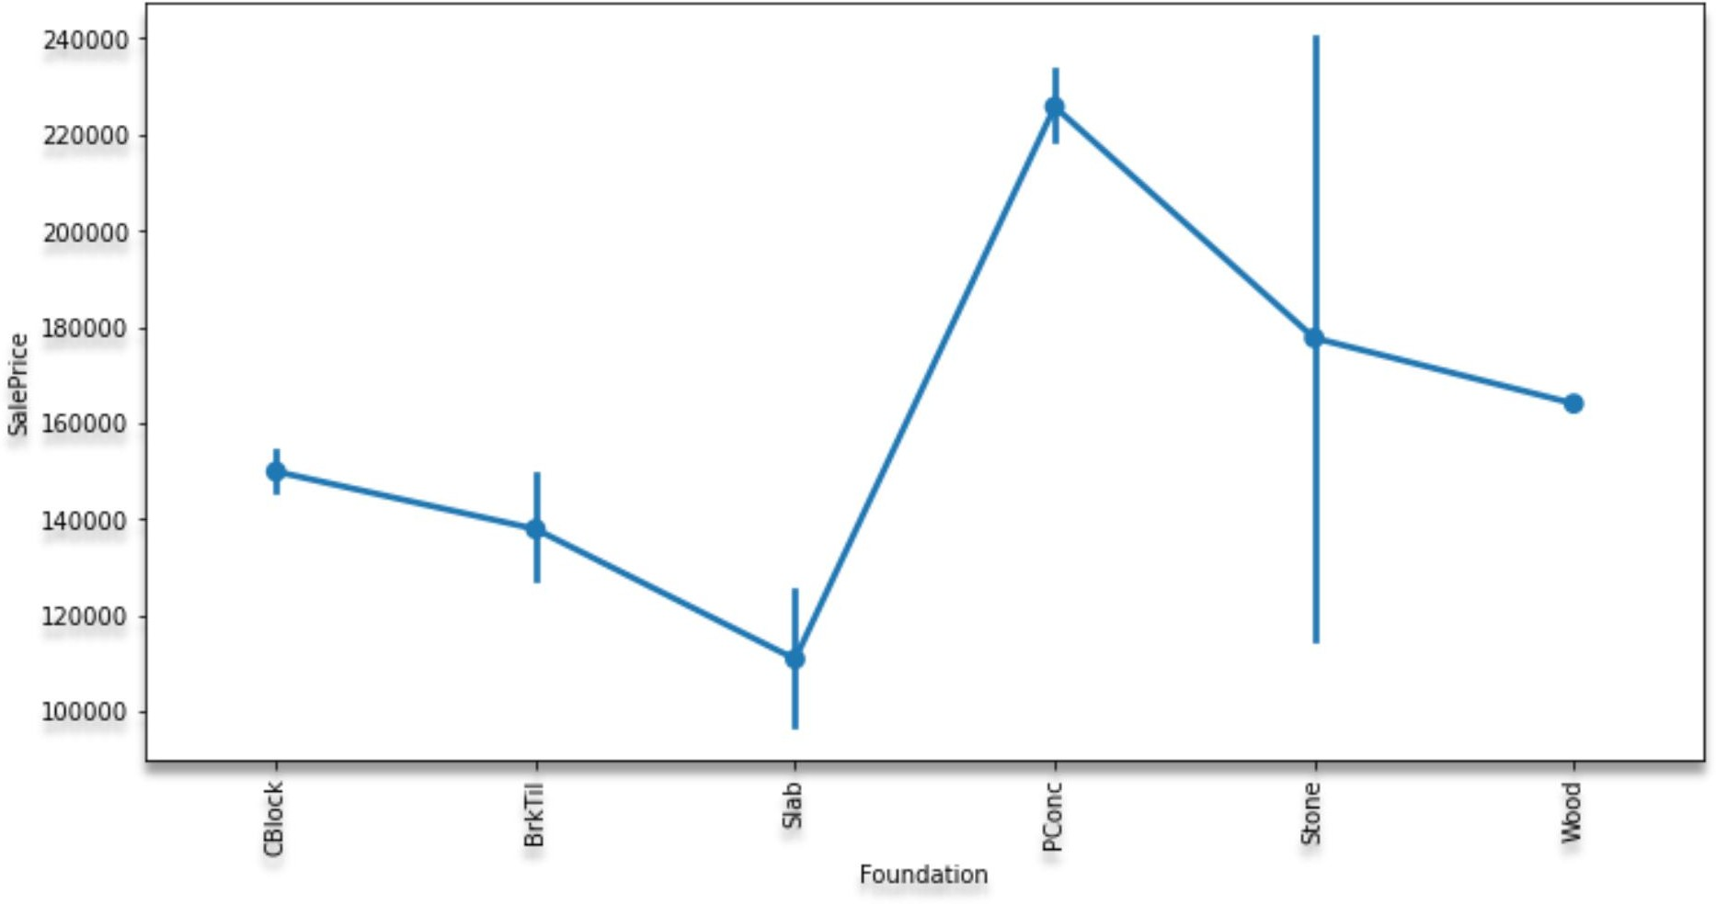

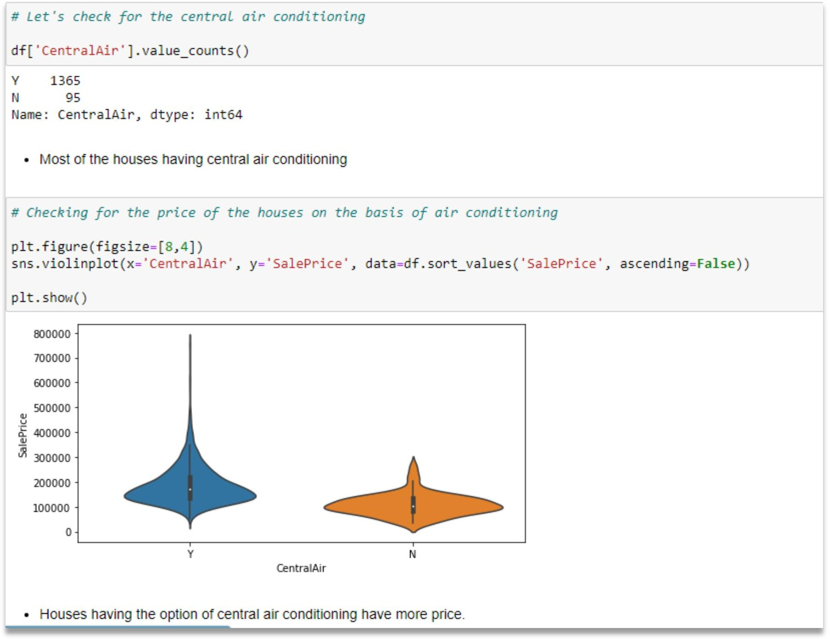

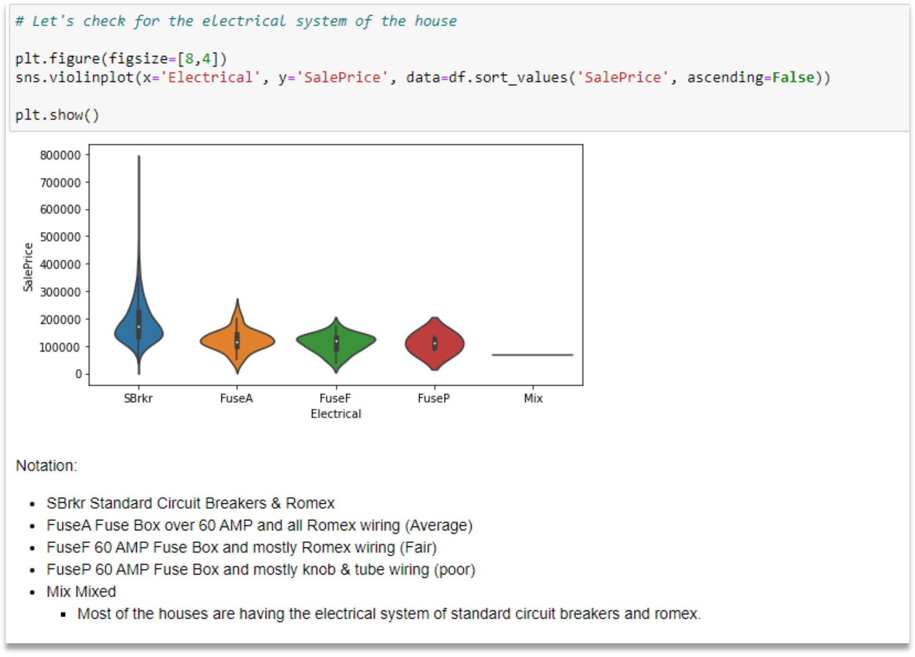

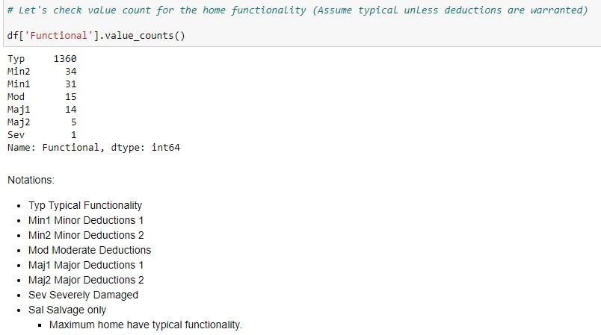

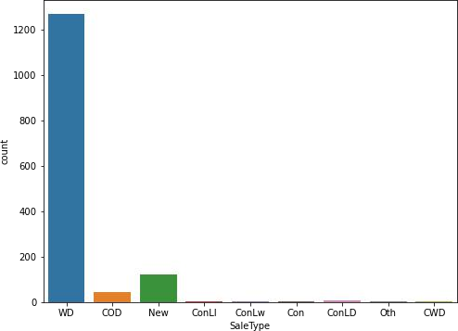

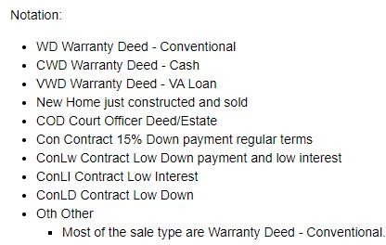

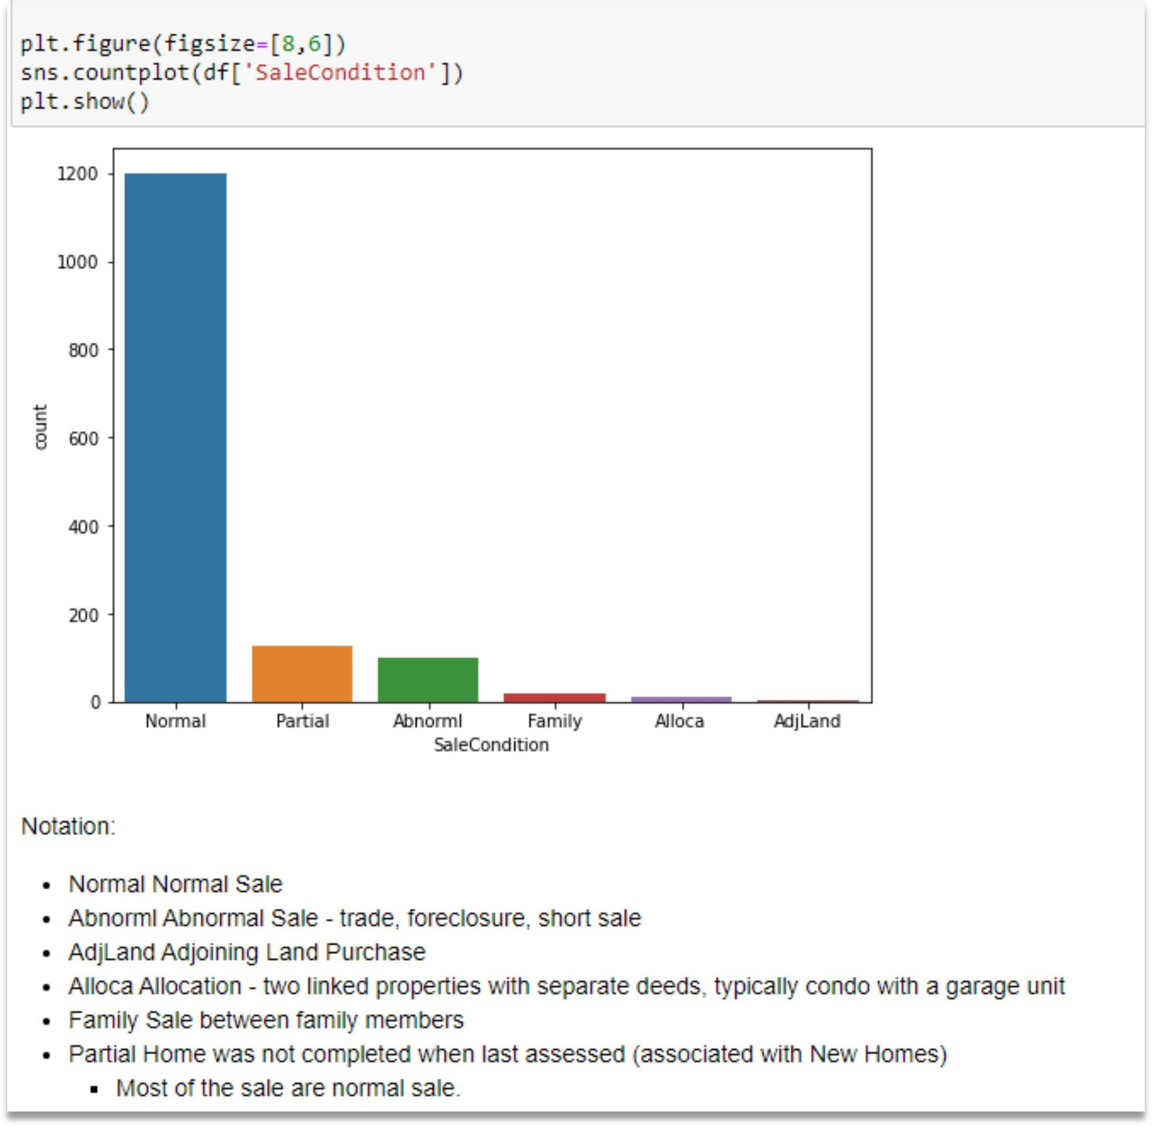

# CONCLUSION

## Key Findings and Conclusions of the given dataset:

* MS Sub Class seems to have the biggest impact on House Prices, followed by Basement Full Bath and Basement Half Bath.
* Other than the Basement related features, Condition 2, Exterior Quality and Lot Area are some of the other important features.

